Georgina Stewart
515211
Contextual Studies
Gender Inequality in Landscape Photography
Word Count (Total including quotes, references, and bibliography): 9181
Word Count (Total including quotes and referencing, excluding bibliography): 5929
Word Count (Excluding Footnotes and Quotations): 5384
Abstract: 465

Abstract

My work looks at the inequality between men and women in landscape photography. In my first chapter, I looked into the reason why there is an inequality in landscape photography. I found that religion, history and tradition have all contributed. The promotion of the Virgin Mary of the ideal women in religion has had far reaching effects into our society. Women are expected to be this ideal women, who can do everything, which is impossible. Jungian archetypes also come into play here. Traditional views that keep women as the homemakers and caregivers are detrimental for women trying to work in landscapes. Views that are derivatives of a patriarchal society are kept alive and dampen a woman’s’ chance in landscape photography. In chapter two, I look at the male gaze and how it is causing harm to the genre. Male and female gazes differ. As men dominate landscape photography an issue arises with their gaze. When we see the world through one gaze, this influences our views in society. We start to believe that men hold the power. It also makes some people believe landscape photography is a male only pursuit as they only see male photographs. The male gaze also causes women to look at other women in the same way. Male and female gazes also influence the photographs people take, their method and aims differ. Artists have tried to highlight this, but they have done so in a way in which needs a male artist as a base for theirs. Problems with the male gaze extends into galleries, where inequality is rife. Men are exhibited more but they also hold the power in how the galleries and institutions are run. Men are also in the majority in the collector sphere. To help the inequality in landscape photography, a complete shake-up of the galleries and institutions is needed. Women need to be in decision-making positions, and the art that is shown should be diversified. Another solution, which will not only help in landscape photography but also in a global sense, can be achieved through pedagogy. Education based not on strict rigid curriculum should be used. Pupils should be able to explore and learn at their own pace. Gender-neutral classrooms for children will have long reaching advantages. This will help the illusion that some roles are for women and some are for men. This will help expand the range in landscape photography, as it won’t be seen as a career that is off-limits to women, the world also won’t be constantly working against them. But from my research, it shows it is difficult to implement these changes. Teachers need to be equipped to be able to deliver this experience in classrooms. Gender inequality can be put right in landscape photography but things will need to change.

Contents

Chapters Page

Introduction 1

Chapter One 2

Chapter Two 7

Chapter Three 15

Conclusion 20

References 21

Figures 26

Bibliography 27
Introduction

“[women] have proved incapable of a single truly great, genuine and original achievement in art, or indeed of creating anything at all of lasting value”
Arthur Schopenhauer
(Quoted in Cowen, 1996)

You may think views like this are rare, but unfortunately they have become fairly engrained. Gender inequality is a familiar oppressive state that is not just found in our society but all over the world. People are now working to bring this oppression to light, but it will be difficult, as civilisation has been indoctrinated with these views for centuries. Inequality can be found almost everywhere, even in the arts. For decades, artists have been trying to address this; art is useful in raising awareness and can help influence the masses; it is a powerful tool. I will be investigating the gender inequality in one specific field: landscape photography. Landscape photography is something that is close to my heart. My earliest memories of starting out with photography are photographing landscape with my family. It has never occurred to me that there would be any inequality here. It was only when I started researching landscapes that I noticed the overwhelming amount of male photographers in this field but the reason behind this inequality remains opaque. I wanted to discover why.

Chapter One

There are many things that have caused and exacerbated inequality. In this chapter I will explore certain causes. I have chosen certain causes because my research has led me here. Whilst other causes have been informative, they didn’t lead me to where I wanted to go.

It is indisputable that landscape photography is a male dominated environment; you can see this on the Internet; if you look for lists of landscape photographers, they are overwhelmingly male (Dautlich, 2017). Landscape photography has the perception of being a masculine genre (Johnson, 2012). Many see it as a hobby or career suited to men (Landscape), and as such it has become a difficult area for women to even get into, let alone work and succeed in (Zhang, 2017). There are reasons for this; history, tradition and religion.

Religion, for example, is an incredibly strong force, which is capable of propagating an idea to the masses. In addition to the belief that women are caregivers and should, more often than not, concede to their husbands, religion has created an impossible platform for women to live up to. For example in the Bible, the issue is exacerbated by the fact that there are not many female figures for women to relate to, yet there are hundreds of male figures. Women seldom feature at the forefront, but when they do feature they are usually portrayed in a negative inferior light. One female figure that women are encouraged to look up to is the Virgin Mary (Warner, 1976, pp. 345).

Religion is powerful and overtime it can influence society’s views and these views of Mary are still affecting women today. I believe religion has promoted the idea of an ‘ideal’ woman in the form of Mary and these views over time have become solidified in our culture and society. It has created a status that no woman can ever live up to. This has contributed to women being oppressed. It also has contributed to the structure of society, as certain attributes and expectations are placed on women. For example, Mary is seen through a variety of roles, she is a virgin, then a bride, a mother, a negotiator, then a queen, but then she is passive but also assertive. She gave birth to the Messiah, an inconceivable achievement, which only she could have done. This led to women expected to be all of these roles, which is not achievable (Warner, 1976, pp. 345). Pope Paul VI attempted to rectify peoples view about Mary, he wanted her viewed as a savior and kept people’s faith (Warner, 1976, pp. 344). He attempted to do this in a letter written in 1974, he urged followers to reconnect to Mary. He wanted to make clear how to show her admiration. He believed that ‘contemporary and modern literature’ has altered people’s perceptions of Mary. He wanted Mary to be viewed as a new woman for people to look up to (Warner, 1976, pp. 15-341). But trying to undo centuries of inequality will be a very difficult task. Mary’s status as the ideal woman is obsolete in today’s world, but for some it is better to have a figure like this than not, especially in a patriarchal religion which centres around important male figures (Warner, 1976, pp. 345). But essentially, you could say that Mary was brought to note and is important, not because she is a strong woman, but for the fact that she is a man’s mother, Jesus. Going by this, the view of her as a role model doesn’t actually start on a good basis for women.

The view of the Virgin Mary has affected women today due to the views that have influenced society for centuries. I think the issue lies with the fact that women have no chance to emulate Mary’s status. Viewed as the ideal woman, where preconceptions and expectations are rolled into one figure, who has been held in high regard for over millennia. The expectation on women to be and do everything could stem from the fact that Mary encompasses all these roles and has been propagated as the ideal. Mary also posed an impossibility that is unachievable, a virgin and a mother at the same time (Warner, 1976, pp. 341-342). So when Pope Paul VI proclaimed the Virgin Mary as the ideal role model for women, the fact that this was unachievable was missed.

But this is not just seen in Christianity, it is a key point in religions and cultures across the world, many of whom are more centered and angled towards men. For example, the idea of the Virgin is popular outside religion. Many believe that the virgin is the synonym of a good mother figure. So much so that according to Jungian archetypes, all men desire a virgin for motherhood, if not only in a symbolic nature. From this male desire, we can see that this idea has a way of reinforcing the idea that a woman’s job is to be a carer and a mother. It may only symbolic, but this symbolism is powerful, it is deeply embedded in our psyche. This could be why the idea of the Virgin Mary has influenced our society deeply (Warner, 1976, pp. 341). It has influenced gender roles and has made it hard to fight the centuries of indoctrination.

Tradition has influenced our social and cultural norms and has influenced the view and expectations placed on women. Whilst men are seen as the worker, women are seen as homemakers and caregivers (Hansson, 2011). The bulk of these responsibilities fall onto the women, making it almost impossible for them to travel and photograph. Men have the biggest advantage here as they are not as restricted, and so can form careers as landscape photographers easier (Miller). Social expectations play a part as women are expected to keep the house and raise the children; they are actively discouraged in life from the travel necessary (Lindermann, Rush and Tepper, 2014). With these impossible odds, some women have been forced to leave their career. Whilst in general those who have succeeded have had significant support and decent circumstances, luck has also been their ally (Cowen, 1996). This uneven division of responsibilities (LSE) has caused an uneven division in the field of landscape photography.

There are no formal qualifications needed for landscape photography today. Early on, some women were restricted and even prohibited from certain careers in art (Brown, 2019). Initially at least when the camera was invented, the equipment hindered women. Cameras and associated equipment were bulky and heavy; many women couldn’t handle it and it was against society’s view of what women could do at the time. You could make the assumption that photography equipment was designed with men in mind (Sebag-Montefiore, 2019). This perception is partly still around, a derivative of a patriarchal society. But as time goes on, gender stereotypes are being addressed, we see some women who are stronger that men, but also vice versa. Rather that being based on one’s gender, it is more about the individual’s strength now. Some men do see themselves as stronger, and many will offer to carry something for a woman if it is heavy, this seemingly small gesture can be traced back to a patriarchal society. As time went on, women did begin to forge artistic careers, but there was a noticeable correlation between them and their Partners’ career (Cowen, 1996). These women were being brought to note not just because of their talent, but due to their partners (Evans, 2018). Their work and their lives were forced under the rules made by and for primarily white men (Schauman, 2001). Though their work was their own, they were still viewed through a patriarchal eye (Evans, 2018).

The problem is these beliefs and expectations are repeated and kept alive. Gender inequality stems from these repeated beliefs and actions. These views have been moulded by society, culture and personal views (Butler, 1990, pp. 185-191). This has created a set of ingrained beliefs. It has become an unconscious thought and action, this is due to the intense conditioning humans have gone through over the centuries (Butler, 1990, pp. xv). This is how gender inequality has managed to take such a strong hold (Butler, 1990, pp. 192). Repeated actions and perceptions play a large role in the inequality in landscape photography. It raises perceptions about the genre as a career, these views may make it seem unsuitable or inaccessible for women. These ideas can cloud reality. People can subconsciously pick their reality. This could also help to explain how people, mainly men, who are not affected by the inequality dispute its existence.

All of these have contributed to a world that works against women. History and tradition have forged the world today. Women’s role in society is solidified as the passive caregivers who couldn’t possibly hold their own in this male dominated world. This has led to certain areas being associated with a gender. For example, the public space is seen as a masculine playground. For women to be in these male dominated areas it is seen as disregarding our social and cultural systems (Bromley, 2019). Public areas are seen as a man’s world. They are associated with being the predators’ domain (Hernandez, 2018). This has in turn caused an issue of safety for women, in particular women working in a man’s world like landscape photography.

With the rise of the Me Too movement, we can now see just how many women have been harassed and attacked. It seems nowhere is completely safe. This has caused some women to reconsider their plans of travelling alone. Teamed with the traditional social norms, people think being a woman out alone is a recipe for trouble (Eszterhas, Stern and McElhinney, 2018). This could be seen as a reason as to why women are not becoming landscape photographers, because it is seen as unsafe for them to do so.

These points have contributed to the inequality in landscape photography we see today. I believe this inequality has a wider reach into how society sees things. If we have been conditioned to view the world through a man’s eyes this becomes an expectation. So by seeing landscape images primarily by men, we may subconsciously believe that it is only appropriate for men to do and that their viewpoint is the correct one. But what if men produced images that were different to that of women’s? Their experiences may cause them to create a different representation. Their gender could influence their approach, their methodology and their images. Within the landscape genre, this could be demonstrative of the male gaze. Artists have recognized this gaze and are fighting against it. In chapter two I will explore the male gaze and look into how artists have dealt with it.

Chapter Two

Landscape photography is still seen masculine job and people have admired it due to that fact; as a result it has created a delusion (Johnson, 2012). These views really have no place in the world today, but they still remain. There are reasons for this; one contributing factor is the male gaze.

Laura Mulvey identified the male gaze. The male gaze refers to the views men experience that empower them. Women are the object of the men’s gaze, so are objectified. The male gaze encourages patriarchy, where toxic masculinity thrives. This gaze allows women to be controlled and to be seen in a way that is gratifying to men. Despite this theory originally involving film and cinema, it goes further into other aspects of life (Loreck). There are male and female gazes; which could refer to the way we view the world. Public areas are a man’s territory; also associated with being a predator’s domain, men can control these areas and thus shape how we see it; they dominate them (Hernandez, 2018). Our reasoning, our aims, how we interpret or just how we look at a scene, would differ.

An artist’s gender may actually influence the art they produce (Brown, 2019). If the majority of landscape images we see are by men, this influences people and society; as we are seeing it through a man’s eye, this can reinforce our expectations of what landscape photography should be. The representation of landscape photography is thus kept constant, and I think it has subtly affected the general public. According to Jill Greenberg, around 90% of images in the media have been taken by a man. If we are seeing the world through a man’s eye, we effectively have the perspective of half the population accounting for the majority of media we see, this has reinforced the idea of who holds the power (Greenberg, 2018). This gendered gaze has long reaching effects, it can be a beacon of oppression (Gerber, 1992) but it also has a way of solidifying the fact that landscape photography is a career for men. As a consequence, if our world is seen through a man’s eye, it creates an illusion, which skews ours perceptions (Cooke, 2017).

Some artists are challenging this male gaze (Foster, 2003); they have put forward their own female gaze (Ogle, 2019). In landscape photography, several artists have put forward their own views of the landscape, challenging the likes of Ansel Adams and Edward Weston. I will be looking at how they have achieved this. But first I want to look at whether Ansel Adams’s male gaze has influenced his images. To do this, I am going to look at a female photographer who was around at the same time to give a comparison, Dorothea Lange; specifically I will look at their respective images of the Manzanar War Relocation Center (Templeman, 2017). The first images are portraits, I am using these to illustrate my point before moving onto the landscape images.

At first glance, Lange’s images show the difficulties that the people faced; they show sorrow. This image (see fig. 1) shows the difficult living conditions. Each ‘room’ has several people and is separate by a cloth sheet. There appears to be a lack of basic comfort. In contrast, here is Adams image (see fig. 2). It shows two people sharing in comfort, very different to the feel of Lange’s image (Templeman, 2017).

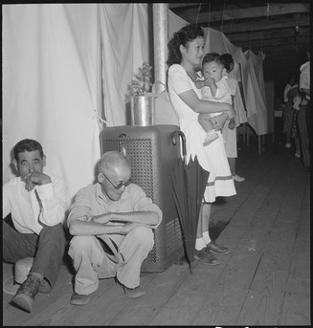
(Fig. 1. Lange. A typical interior scene in one of the barrack apartments at this center. Note the cloth partition which lends a small amount of privacy)
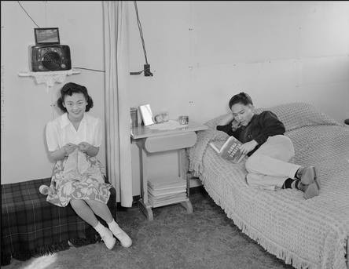
(Fig. 2. Adams. Mr. & Mrs. Dennis Shimizu)

Adams’s next image (see fig. 3) shows a women practicing with a baton, she appears very happy and unrestricted. Yet in Lange’s image (see fig. 4) there is a boy and his grandfather, both looking unhappy (Templeman, 2017).

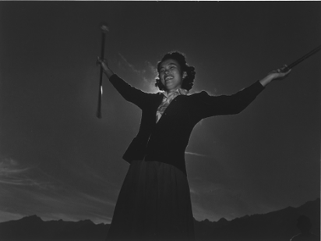
(Fig. 3. Adams. Baton practice. Florence Kuwata)
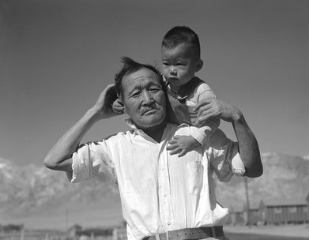
(Fig. 4. Lange. Manzanar Relocation Center, Manzanar. California. Grandfather and Grandson of Japanese Ancestry at This War Relocation Authority Center)

These next images are of the landscape. Lange’s image (see fig. 5) shows the campgrounds. The mountains are in the background and the American flag is flying high. Here we see the paradox of a symbol of freedom in a concentration camp. In contrast Adams’s image (see fig. 5) concentrates on the landscape surrounding the camp, you wouldn’t necessarily know there was a camp there (Templeman, 2017).
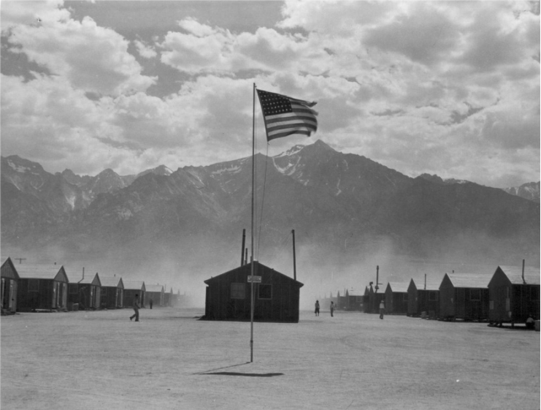
(Fig. 5. Lange. A View of the Quarters at Manzanar, California, a War Relocation Authority Center Where Evacuees of Japanese Ancestry Will Spend the Duration)
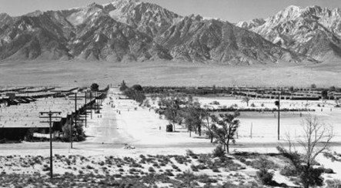
(Fig. 6. Adams. Manzanar Relocation Center from Guard Tower)

Adams images show hope and comfort. But Lange’s show the real desperation and sorrow. There is a stark contrast. Own personal circumstances may account for someone’s approach. Dorothea Lange worked for the Farm Security Administration. The FSA was a new deal bureau, which was founded to help poverty in rural areas (Weisner-Alexander, 2019). This would have had an influence on the images Lange took. Her images usually focused on people. But for this, the government commissioned Lange to photograph the relocation of the people. Lange wanted to show a true representation of the camp but after completing the task, she met resistance. The military personnel were not happy with what was portrayed, so they confiscated them. Lange was influenced by the FSA, but in this instance wanted to show a true representation of the camp but the military didn’t want these images shown (Chambers, 2017). Adams also wanted to show a true representation, but for him, it was to show how “these people, suffering under a great injustice, and loss of property, businesses and professions, had over come the sense of defeat and dispair [sic] by building for themselves a vital community in an arid (but magnificent) environment” (Adams, quoted in Library of Congress).

Adams wanted to created a war project with meaning, and for him, Manzanar was it. As with Lange, Adams was hired by the government. He felt he was addressing the issues of the camps by showing the people as normal patriotic Americans. Adams and Lange’s approach was similar, however their results were very different (Florido, 2016).

I think the difference between the gazes is how we see things. Many of Lange’s images show struggle, they show an imperfect world. Adams’s images show the opposite. If you saw them, you may think the centre is fine, people are happy, but in truth you are only seeing one side. The same could be said for Lange; but really it could be more damaging believing completely in Adams’s images. Perhaps our gazes are influenced by the expectations placed on the different genders. Women are expected to be caring and more emotional, this could influence how we explore and see the world. This could be another reason why Lange’s images are more emotional (Templeman, 2017).

Some believe Adams’s approach was due to his male gaze and this influenced his images. Some female artists have used the landscape and Adams’s work as a platform to highlight and fight the inequality, but also to draw attention to their female gaze. One such photographer is Catherine Opie.

Opie’s series, As long as they are wild, documents her exploration of Yosemite National Park as a feminist (Tsui, 2018). The series contains blurry images. When you look deeper, you can see her reasoning (Tam). Her image, Untitled #2 (see fig. 5), reminds me of Ansel Adam’s Mirror Lake (see fig. 6).


(Fig. 7. Untitled #2 (2015))

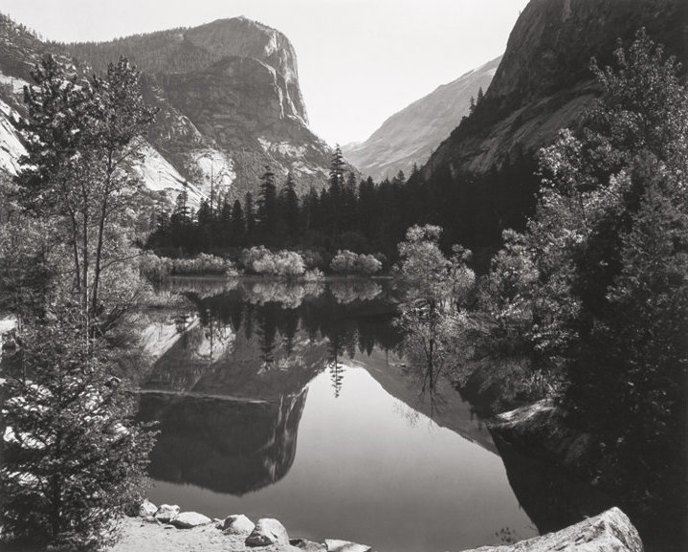
(Fig. 8. Mirror Lake (1925))

It strikes me that she is taking a stand against the traditions of landscape photography and showing her view as a feminist, but also shows a loss of identity (Tam).

Terri Loewenthal is an artist who also believes that gazes differ. In her series Psychscapes, Loewenthal explores the same landscapes that Adams did. She doesn’t see her work as feminist art but rather raises the point that she is a woman and men would not take her approach. Loewenthal wants the viewer to escape the bonds of perception. Her images are brightly coloured (see fig. 7), and promote a spiritual vision; a connection arises of emotion and spirituality. Psychscapes was exhibited next to Adams’s at the Jackson Fine Art Gallery in Atlanta. The purpose was to highlight the difference between the gazes, demonstrating how their gender influenced their methodology (Palumbo, 2019).

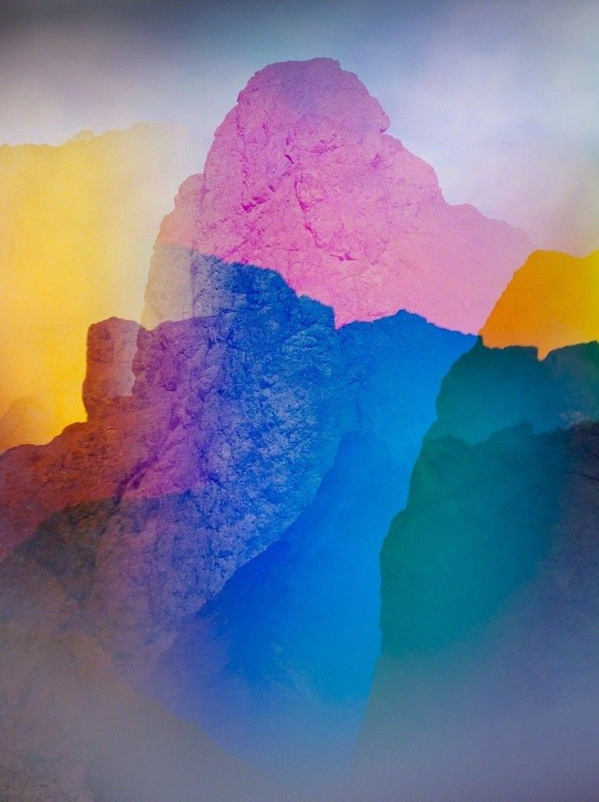
(Fig. 9. Psychscape 602 (White Rock Canyon, AZ (2018)).

The main issue that arises in Opie’s and Lowenthal’s work is that they rely on Adams’s for theirs to work. They have chosen to highlight their own gaze and fight against the male gaze, but have done so in a way which needs Adams’s work. This is not a great base for fighting against the male gaze. Artists cannot truly fight the male gaze and the inequality if they are basing their work on a man’s. This is a problem artists must overcome if they are looking at gazes.

The technical side of things is something Opie and Loewenthal used in their work to differentiate the gazes. Adams images are sharp, in focus and meticulously detailed, Opie’s and Loewenthal’s are blurry. They believe that Adam’s images are technically perfect because of his gaze. The issue is that technical perfection is not indicative of gender and the fact remains that they are still reliant on a man to make their work make sense. They highlight their own female gaze and challenging the male gaze but not successfully enough to not need a male artist to do so (Palumbo, 2019).

Adams’s approach may be indicative of his male gaze. He scoured the landscape in an obsessive predatory way. This mirrors the fact that the landscape is seen as a predator’s playground (Hernandez, 2018). He photographs the harsh wild rugged terrain, which gives a masculine feel to it. His images look strong, primordial and naturally masculine. Adams controlled his visions, which empowered him. His approach, his views and his obsession are indicative of his male gaze (Loreck). The power of nature has been masculinised. Landscape is a masculine domain (Mays, 2005). The masculinity teamed with the embodiment of the ego is the male gaze over the landscape (Mulvey, 2007). Seeing the world through a man’s eyes has the ability to solidify their views in our society. It also has ensured that landscapes are seen as a masculine pursuit (Palumbo, 2019).

“To gaze implies more than to look at - it signifies a psychological relationship of power and sexuality in which the gazer dominates the object of the gaze” (Schroeder & Zwick, 2004, p. 30). In general nature is associated with women. The male gaze has been able to make the feminine landscape into a masculine realm (Mays, 2005). The men hold the authority and thus an imbalance in power is formed (Loreck, 2016). This has led to a hegemonic society. Hegemony is where a dominant faction of society, in this case, men, can exercise power over others (Merriam-Webster - Hegemony). Men have the ability to control the landscape, so women are few and far between (Loreck). This control shows their power (Mulvey, 2007). Women are forced to look through the male gaze, and as such they regard women in the same way as men do. So seeing a male landscape artist’s images, a woman subconsciously relates to him and keeps the belief that it is a man’s territory. These views stay; they underlie our natural order and now become the norm in our society. We become influenced by these learned systems. Landscape photography is a male associated genre, the masculinity here has become a habit and will continue to be due to the underlying views the structure our world (Shroeder & Zwick, 2004). “The photograph both mirrors and creates a discourse with the world, and is never despite its often passive way with things, a neutral representation” (Clarke, 1997, p. 27-28). Art holds external values that are hard to break (Yrgel, 2019). It can hold a value that doesn’t actually relate to the subject and can create false expectations. This causes people to see a certain genre and believe a certain viewpoint attached to it, this can be detrimental to that genre as the views become attached to it and can cause misconceptions. Despite this, female artists have and are continuing to highlight the inequality and to fight it.

Chapter Three

Groups such as the Guerrilla Girls are known for their feminist activism. They have highlighted the stark inequality in the amount of men exhibiting in galleries against the amount of female artists. The male gaze can be found in galleries and institutions. Galleries are one particular institution that could help the fight. I believe some are exacerbating the issue, one curator was quoted stating that, “I just curate what I like, and I like art by men better” (Curator quoted in Sterling, 2016). Painter, George Baslitz stated that “women don’t paint very well. It’s a fact” (Baslitz, quoted in Elderton, 2013). The people in positions of power are still predominantly male and they feel confident making these statements (Miller). Around 22% of solo shows in London are by women whereas only 2% of art by deceased artists in London are by women (Steedman, 2017). The problem stems from the structuring of these institutions (Louise, 2015). There is a lack of women in decision-making roles, including curators and even collectors (Brown, 2019). Men are in the majority in the collectors’ sphere. But collectors don’t just buy the art, they are involved directly in the running and structure of the galleries; they are a part of the boards and have power (Elderton, 2013). People purchase art that is seen as desirable, usually recommended by galleries, but these are still dominated by men. This has led to a subconscious thought in our society, that art by women is unworthy. Many dislike women with power (Evans, 2018). These collectors have the power to influence what art is available and displayed in the galleries, any bias here will come to light. I believe some people deliberately believe art by men is better that art by women. In a study where computer generated images were labeled with a made-up name. The images seemingly created by men were valued higher than their female counterparts, simply because they are a man (Vedantam, 2018). This mentality can be salvaged, and women are trying to fight this. Yet there is still a lack of women in the positions of power, and there is definitely a lack of female representation at exhibitions and in galleries. This may be helped by diversifying what art is displayed (Tate). The other side to this may become a problem, as forced selection based on gender may actually excluded some brilliant work but it will also give the sense of falseness to the selection. Many hope this equality will be reached; Anthony Spinello hopes that “one day no need for all women exhibitions” (Spinello quoted in Zara). But if this is going to be achieved, the mentality of belief that male art is better needs to change, this will be a very difficult thing to do. This will be especially difficult in the male-dominated field of landscape photography. But there are plenty of female landscape artists. Networking could be an issue here too, men are more likely to rely on networks but it is a treacherous world (Lindermann, Rush and Tepper, 2014). The truth is, that you are more likely to see work by Andreas Gurksy in a gallery than Jean Day. It is possible that due to a number of factors including bias, structuring, society and networking that this fact will remain for a long time, it’s not as simple as his work being better than hers, there is a lot more going on behind the scenes (Cooke, 2017). A complete change in attitudes and mentality will need to happen, also galleries should diversify and hopefully one-day someone’s art wont’ be dependent on their gender.

Whilst issues can be found in galleries and in the commercial sectors, a case can be made for the problem stemming from education (Nochlin, 1973). I believe gender inequality, in particular in the arts can improved through education, specifically through a pedagogical approach. Pedagogy is “the art, science, or profession of teaching” (Merriam-Webster – Pedagogy). Pedagogy is effectively a caring relationship, which encourages and allows the pupil to flourish (Smith, 2020). The relationship between the teacher and pupil is key; there must be trust (Wahjusaputri, 2015). Pedagogy for children is more than school education. Children can learn, explore and discover at their own pace, with strong encouragement from a trusted adult. This style of learning has its benefits, it gives children a chance to learn at their own pace by exploring and it gives them the ability to question and reflect. The problem with school-based education is that there is a heavy reliance on curriculums and rigid exercises (Encyclopedia - Cengage). There is a need for structural learning, but it should be balanced with the pedagogical approach and exploration and reflection (Macloed and Golby, 2003). The same is true for adult pedagogy. Andragogy was once used to describe pedagogy for adults, however, the root of the word comes from the Greek meaning ‘man’, and so it doesn’t have a strong start for gender equality. It was never an accepted term by academia. Pedagogy for everyone is beneficial to society as a whole. Education for adults is important as it can still teach and address some aspects of gender inequality. But being able to teach young children in a gender-neutral pedagogy programme has advantages as they are taught equality young (Smith, 2020).

Pedagogy in art-specific subjects can take a different approach. The emphasis is on exploring one’s creativity and therefore learning through your artwork (Pringle, 2009). By exploring your own ideas, experimenting with different techniques, conducting wider research, taking risks, and reflecting on your findings, you will gain a very different insight to your work (Tarr, 1996). Pupils can flourish, they can choose what they want to do which builds on their imaginations. Due to the rigid focus on curriculum, pedagogy will not work in schools. Teachers need to tailor their approach to what each child needs, but this isn’t always possible (Pearse, Snide and Taylor). Reasons are class sizes, lesson times and the fact teachers aren’t trained to do this (Ewing). Teaching is focus on textbook learning, which doesn’t allow children to utilise their full potential. Art should be a practical subject, with some knowledge. To thrive, pupils need the opportunity to grow and explore on their own, but with the back up of a trusted teacher (Pearse, Snide and Taylor).

I believe pedagogy could play an important role in promoting gender equality. It would help break barriers of what is perceived to be an acceptable genre to work in, as it lets the children grow up finding their own artistic voice and following their passions. Pedagogy could help stop gender inequality before it takes hold. This would help in landscape photography, as there would be no expectations or learnt gender roles. It is believed that children learn about gender between ages three and seven (Rooms and Mchwezi, 2019). This is the point where any negative view of gender will have long lasting effects. If changes are made to the way teachers teach, this could have a positive effect. At the moment, schooling is set by a curriculum, which also brings in the teachers attitude, which has been shaped by their own lives (UNESCO). This will influence the children. Teachers may be reinforcing the idea of gender roles and associating tasks with gender stereotypes; as a result by the time children are seven they would have already been affected. But if gender conscious pedagogy was introduced, children may not be affected by gendered concepts. Classrooms would be gender neutral.

Teachers need to be trained and willing to adapt. The Ugandan government decided to introduce gender-neutral pedagogy into their schools. Whilst they found benefits for the girls, they also found that the teachers quickly reverted to the standard rigid curriculum. Many didn’t feel they were equipped to implement the changes, others didn’t feel that it was their job to empower their female students. Here, is a clear problem with implementing the changes. This problem could stem from asking teachers to completely change how they have been taught and how they have taught, they may either be stuck in their ways or simply unable to change their teaching habits (Nabbuye, 2018). I believe for pedagogy to be effective in tackling gender inequality, teachers training needs to be addressed. If trainee teachers are taught to use pedagogy, then they will be equipped to use it effectively. This has been done in countries like Sweden and Finland, who in general have good equality. In Sweden, universities began incorporating pedagogical learning into their courses since the 1970s. Their qualified teachers are better equipped and trained to deliver a gender-neutral classroom experience, which provides a better learning experience (Kreitz-Sandberg, 2016). This way of teaching has proved valuable, and is being successfully used in other countries (Ylostalo and Brunila, 2017). But Nordic countries tend to be more politically aware, and more aware of gender, so culturally they are at an advantage. For this method to be successful, training for the teachers need to begin at the start of their studies. The teachers will benefit, they will be fully aware and able to implement the method in their classrooms, which will benefit the children and society in general.

Better representation in the media and galleries and better education would provide a good platform to fight the inequality, not just in landscape photography but also across the board. I believe education is key. But for it to work, people must change, however many don’t want to. Even though the solutions may work, it will be hard to break centuries of tradition.

Conclusion

I have looked at how gender inequality has arisen and the factors that have contributed to it remaining at the forefront of inequality in the arts. I believe galleries and the commercial sector can help the issue now, but education can provide a long lasting solution that can help and inspire generations to come. Gender inequality in landscape photography is not going to go away over night. The steps that have been made in recent decades show we are heading in the right direction, but there is still a long way to go. The male gaze has been instrumental in propagating gender inequality in landscape photography; seeing the world through a man’s eye has warped our view of gender roles, which has made it more acceptable to be a man photographing the landscape. Saddled with expectations, despite the progress made, women are expected to do everything. For a genre like landscape photography, these expectations alongside the male dominance makes it a difficult and unsuitable career for a woman; but it doesn’t have to be. Through consistent education, gender inequality can be fixed, but people must want to make a difference. Although gender inequality does affect both men and women, some people still deny that it is a problem, and this becomes a problem in itself. We need people to fight against it, for our own sakes and for the future generations. I believe people have been successful in highlighting this issue in general but in landscape photography female artists are drowned out by the vastness of the male presence.

Reference

Bromley, C (2019) Could a woman walk around the world today? At: https://www.nationalgeographic.com/culture/2019/04/could-woman-walk-around-world-today/ (Accessed on 30th of August 2019).
Brown, T. W. (2019) Why is work by Female Artists Still valued less the work by Male Artists? At: https://www.artsy.net/article/artsy-editorial-work-female-artists-valued-work-male-artists/ (Accessed on 27th of August 2019).
Butler, J (1990) Gender Trouble. Reprint, UK: Routledge, 2007.
Chambers, T (2017) Dorothea Lange’s censored photographs of FDR’s Japanese Concentration Camps. At: https://anchoreditions.com/blog/dorothea-lange-censored-photographs (Accessed on 8th of July 2020).
Cooke, A (2017) Is photography overrun by white males? At: https://fstoppers.com/originals/photography-overrun-white-males-160839 (Accessed on September 2019).
Cowen, T (1996) ‘Why Women Succeed, and Fail, in the Arts’ In: Journal of Cultural Economics (vol. 20) pp. 93-113.
Dautlich, A (2017) Women in landscape photography. At: https://www.aprildautlich.com/blog/2017/9/19/women-in-landscape-photography-its-not-1950-anymore-people (Accessed on 23rd of August 2019).
Elderton, L (2013) Redressing the Balance: Women in the Art World. At: http://www.thewritereview.org/feature/redressing-the-balance-women-in-the-art-world/ (Accessed on 10th of September 2019).
Encyclopedia - Cengage (2020) Problems, pedagogy and problem-based learning. At: https://www.encyclopedia.com/education/applied-and-social-sciences-magazine/problems-pedagogy-and-problem-based-learning/ (Accessed on 17th of April 2020).
Eszterhas, S, M. Stern and S. McElhinney (2018) Nature Photography: Where Are the Women? At: https://petapizel.com/2018/03/22/nature-photography-where-are-the-women/ (Accessed on 6th of September 2019).
Evans, A (2018) Female Artists who Greatly Influenced Gender Equality. At: https://news.masterworksfineart.com/2018/03/17/the-female-artists-who-greatly-influenced-gender-equality (Accessed on 11th of September 2019).
Ewing, R. Making a difference in learning through arts-rich pedagogy. At: https://research.acer.edu.au/cgi/viewcontent.cgi?articles=1331&context=research_conference (Accessed on 17th of April 2020).
Florido, A (2016) Photos: 3 very different views of Japanese Internment. At: https://www.npr.org/sections/codeswitch/2016/02/17/466453528/photos-three-very-different-views-of-japanese-internment?t=1594904537639/ (Accessed on 16th of July 2020).
Foster, D. W (2003) ‘Defying the masculinist gaze: Gabriela Liffschitz’s “Recurious Humanos” In: Chasqui (vol. 32, no. 1) pp. 10-24.
Gerber, E (1992) ‘Feminism, Aesthetics, and Art Education’ In: Studies in Art Education (vol. 33, no. 4) pp. 210-225.
Greenberg, J (2018) The female lens. At: https://alreadymade.org/the-female-lens/ (Accessed on 1st of September 2019).
Hansson, L (2011) ‘Gender Role Attitudes’ In” Vetik, R. and J. Helemae (ed.) The Russian second generation in Tallinn and Kohtla-Jarve. Amsterdam: Amsterdam University Press. pp. 183-202.
Hernandez, C (2018) LoMo In-Depth: Women Photographers on Gender Inequality. At: https://www.lomogallery.com/magazine/336380-lomo-in-depth-women-photographers-on-gender-inequality (Accessed on 8th of September 2019).
Johnson, M (2012) ‘Landscape Studies: The future of the field’ In: Kluving, S. J. and E. B. Gruttmann-Bond (ed.) Landscape Archaeology between Art and Science. Amsterdam: Amsterdam University Press. pp. 515-525.
Kreitz-Sandberg, S (2016) ‘Improving Pedagogical Practices through Gender Inclusion: Examples from University Programmes for Teachers in Preschools and Extended Education’ International Journal for Research on Extended Education. vol. 4, no. 2, pp. 71-91.
Landscape. Women in Landscape Photography. At: https://landscapephotographymagazine.com/2018/women-in-landscape-photography/ (Accessed on 23rd of August 2019).
Library of Congress. Ansel Adams’s Photographs of Japanese-American Internment at Manzanar. At: https://www.loc.gov/collections/ansel-adams-manzanar/about-this-collection/ (Accessed on 15th of July 2020).
Lindermann, D. J, C. A. Rush and S. J. Tepper (2014) ‘An asymmetrical portrait: Exploring Gendered Income Inequality in the Arts’ In: The Southern Sociological Society (vol. 3, no. 4) pp. 332-348.
Lindermann, D. J, C. A. Rush, S. Tepper. An asymmetrical portrait. At: https://asu.pure.elsevier.com/en/publications/an-asymmetrical-portrait-exploring-gendered-income-inequality-in- (Accessed on 9th of September 2019).
Loreck, J (2016) Explainer: What does the ‘male gaze’ mean, and what about a female gaze? At: https://theconversation.com/explainer-what-does-the-male-gaze-mean-and-what-about-a-female-gaze-52486 (Accessed on 2nd of July 2020).
LSE. Confronting Gender Inequality. London: Gender Institute.
Macleod, F and M. Golby (2003) ‘Theories of Learning and Pedagogy: issues for teacher development’ Teacher Development. vol. 7, no. 3, pp. 345-362.
Mays, S (2005) Ansel Adams: The Gender Politics of Literary-Philophical and Photographic Archives. In: Photography and Literature in the Twentieth Century by D. Cunningham, Fisher, A, & Mays, S (eds) Cambridge Scholars Publishing, UK. pp. 87-109.
Merriam-Webster. Hegemony. At: https://www.merriam-webster.com/dictionary/hegemony (Accessed on 17th of July 2020).
Merriam-Webster. Pedagogy. At: https://www.merriam-webster.com/dictionary/pedagogy (Accessed on 22nd of July 2020).
Miller, D. L ‘Gender and the Artist Archetype: Understanding Gender Inequality’ In: Sociology Compass [Online] At: http://onlinelibrary.wiley.com/doi/10.1111/soc4.12350/abstract (Accessed on 12th of September 2019).
Mulvey, L (2007) ‘Visual Pleasure and Narrative Cinema’ In: Evans, J and S. Hall (ed.) Visual Culture: A Reader. UK: Sage Publications Ltd. pp. 381-389.
Oliver, K (2017) The male gaze is more relevant, and more dangerous, than ever, New Review of Film and Television Studies (vol. 15, no. 4) Routledge: USA, pp. 451-455.
Nabbuye, H (2018) Gender-sensitive pedagogy. The bridge to girls’ quality education in Uganda. Washington: Brookings Global, pp. 1-19.
Nochlin, L (1973) ‘Why have there been no great women artists?’ In: Hess, T. B & E. C. Baker (ed.) Art and Sexual Politics. UK: MacMillian. pp. 1-39.
Ogle, L (2019) ‘Confused Cats and Postfeminist Performance’ In: De Kosnik, A and K. P. Ferdman (ed.) #identity. USA: University of Michigan Press. pp. 123-136.
Palumbo, J (2019) Did Ansel Adams’s male gaze influence his landscape photography? At: https://www.artsy.net/article/artsy-editorial-ansel-adamss-male-gaze-influence-landscape-photography (Accessed on 31st of March 2020).
Pearse, H, A. B. Snide & C. Taylor. ‘The lost art of Pedagogy’ The Canadian Review of Art Education. vol. 38, pp. 5-16.
Peeler, D. P (1989) The Romance of Platonic Forms: Edward Weston and Ansel Adams, Colby Library Quarterly (vol. 25, no. 2) pp. 92-105.
Pringle, E (2009) The Artist as Educator. At: https://www.tate.org.uk/research/publications/tate-papers/11/artist-as-educator-examining-relationships-between-art-practice-and-pedagogy-in-gallery-context (Accessed on 17th of April 2020).
Rooms, S & M. Mchwezi (2019) Teaching gender equality to the youngest learners. At: https://www.globalpartnership.org/blog/teaching-gender-equality-youngest-learners (Accessed on 17th of April 2020).
Schauman, S. (2001) ‘Gender/ Ethnicity/ Landscape’. In: Women’s Studies Quarterly, pp. 261-274.
Schroeder, J. E & D. Zwick (2004) Mirrors of Masculinity: Representation and Identity in Advertising Images. Consumption, Markets and Culture (vol. 7, no. 1) pp. 21-52.
Sebag-Montefiore, C (2019) Women battling sexism in photography – a picture essay. At: https://www.theguardian.com/artanddesign/2019/mar/07/women-battling-sexism-in-photography-a-picture-essay/ (Accessed on 28th of August 2019).
Smith, M. K (2020) What is Pedagogy? A definition and discussion. At: https://infed.org/mobi/what-is-pedagogy/ (Accessed on 17th of April 2020).
Steedman, M (2017) Representation of Female Artists in Britain in 2017. At: https://www.freelandsfoundation.co.uk/documents/Representation-of-female-artists-research-2018.pdf (Accessed on 11th of September 2019). Louise, D (2015) Women and contemporary Art: Why gender inequality is still an issue. At: https://www.a-n.co.uk/news/women-and-contemporary-art-why-gender-inequality-is-still-an-issue/ (Accessed on 27th of August 2019).
Sterling, S. F. (2016) What we’re doing about gender inequality in the Arts. At: https://www.huffpost.com/entry/what-were-doing-about-gender-inequality-in-the-art_b_57f3cd00e4b0f482f8f0bdbf (Accessed on 30th of August 2019).
Tam, P. So Long As They Are Wild. Catherine Opie. At: http://artasiapacific.com/Magazine/WebExclusives/SoLongAsTheyAreWild (Accessed on 24th of July 2019).
Tarr, J (1996) ‘Arts Education: a process approach to the development of Pedagogy’ Journal of In-Service Education, vol. 22, no. 3, pp. 293-308.
Tate. What does it mean to be a woman in art? At: https://www.tate.org.uk/art/tate-exchange/women-in-art (Accessed on 22nd of August 2019).
Templeman, C. (2017). Photographic Comparison: Lange and Adams. Available at: http://langeandadamstakingastand.weebly.com/comparison.html# (Accessed on 2nd of September 2019).
Tsui, E. (2018). Yosemite in all its intimacy: feminist photographer Catherine Opie’s first solo Hong Kong show features Western landscapes. At: https://www.scmp.com/culture/arts-entertainment/article/2147211/yosemite-all-its-intimacy-feminist-photographer-catherine (Accessed on 24th of July 2019).
UNESCO (2015) A Guide for gender equality in teacher education policy and practices. France: UNESCO, pp. 1-112.
Vedantam, S (2018) Researchers explore Gender Disparities in the Art World. At: https://www.npr.org/2018/09/18/649060336/researchers-explore-gender-disparities-in-the-art-world?=1568298087357 (Accessed on 3rd of September 2019).
Wahjusaputri, S (2015) ‘Current issues in pedagogy and practice for early children, elementary and secondary education’ Indonesia Journal of Educational Review. vol. 2, no. 2, pp. 29-37.
Warner, M (1976) Alone of All Her Sex: The Myth and the Cult of the Virgin Mary. Oxford: Oxford University Press.
Weisner-Alexander, K (2019) Farm Security Administration – A New Deal. At: https://www.legendsofamerica.com/20th-fsa/ (Accessed on 8th of July 2020).
Ylostalo, H & K. Brunila (2017) ‘Exploring the possibilities of gender equality pedagogy in an era of marketization’ Gender and Education. vol. 30, no. 7, pp. 917-933.
Yrgel, C (2019) Literature Review: Landscape’s Revenge. De Gruyer. pp. 11-46.
Zara, J (2017) An all female art fair takes on Gender Inequality with a show at a Miami Shopping Mall. At: https://news.artnet.com/art-world/art-fair-gender-inequality-miami-1174916 (Accessed on 8th of September 2019).
Zhang, C (2017) Where are all women artists? An analysis of gender inequality in the realm of the arts. At: http://kinea.media/en/human-sciences-women-artists-men-inequalities (Accessed on 30th of August 2019).

Figures

Fig. 1. Lange, D. “A typical interior scene in one of the barrack apartments at this center. Note the cloth partition which lends a small amount of privacy” [Photograph – Online]. Available at: http://langeandadamstakingastand.weebly.com/comparison.html# (Accessed on 2nd of September 2019).
Fig. 2. Adams, A. Mr. & Mrs. Dennis Shimizu. [Photograph – Online]. Available at: http://langeandadamstakingastand.weebly.com/comparison.html# (Accessed on 2nd of September 2019).
Fig. 3. Adams, A. Baton practice. Florence Kuwata. [Photograph – Online]. Available at: http://langeandadamstakingastand.weebly.com/comparison.html# (Accessed on 2nd of September 2019).
Fig. 4. Lange, D. Manzanar Relocation Center, Manzanar. California. Grandfather and Grandson of Japanese Ancestry at This War Relocation Authority Center. [Photograph – Online]. Available at: http://langeandadamstakingastand.weebly.com/comparison.html# (Accessed on 2nd of September 2019).
Fig. 5. Lange, D. “A View of the Quarters at Manzanar, California, a War Relocation Authority Center Where Evacuees of Japanese Ancestry Will Spend the Duration” [Photograph – Online]. Available at: http://langeandadamstakingastand.weebly.com/comparison.html# (Accessed on 2nd of September 2019).
Fig. 6. Ansel, A. “Manzanar Relocation Center from Guard Tower” [Photograph – Online]. Available at: http://langeandadamstakingastand.weebly.com/comparison.html# (Accessed on 2nd of September 2019).
Fig. 7. Opie, C. (2015). Untitled #2 (Yosemite Valley). [Photograph – Online]. At: https://ocula.com/art-galleries/Lehmann-mauling/artworks/Catherine-opie/Untitled-2-yosemite-valley/ (Accessed on 24th of July 2019).
Fig. 8. Adams, A. (1925). Mirror Lake. [Photograph – Online]. At: https://shop.anseladams.com/mirror_lake_signed_special_edition_photograph_p/1701807106.htm(Accessed 24th of July 2019).
Fig. 9. Loewenthal, T. (2018). Psychscape 602 (White Rock Canyon, AZ). [Photograph - Online]. At: https://www.artsy.net/artwork/terri-loewenthal-psychscape-602-white-rock-canyon-az-1 (Accessed on 1st of May 2020).

Bibliography

AHRC. A question of class: how do social inequality metrics work in cultural organisations? At: https://ahrc-blog.com/2018/10/26/a-question-of-class-how-do-social-inequality-metrics-work-in-cultural-organisations/ (Accessed on 7th of September 2019).
Americans for the Arts. Social Inequality and the Arts. At: https://www.americansforthearts.org/by-program/reports-and-data/regislation-policy/naappd/social-inequality-and-the-arts/ (Accessed on 7th of September 2019).
Arts Award. Women in Art, inequality and underrepresentation. At: https://www.voicemag.uk/blog/3899/women-in-art-inequality-and-underrepresentation/ (Accessed on 23rd of August 2019).
Asega, S (2018) What happens when artists use tech to confront inequality? At: https://www.fordfoundation.org/ideas/equals-change-blog/posts/what-happens-when-artists-use-tech-to-confront-inequality/ (Accessed on 27th of August 2019).
Atlantic Fellows. Art and Inequality: New Perspectives. At: https://afsee.atlanticfellows.org/events/2018/art-and-inequality-new-perspectives/ (Accessed on 10th of September 2019).
Barthes, R (2007) ‘Rhetoric of the image’ In: Evans, J and S. Hall (ed.) Visual Culture: a Reader. UK: Sage Publications Ltd. pp. 33-40.
Baudrillard, J. (2001) Selected Writings. USA: Stanford University Press.
Baudrillard, J (1994) Simulacra and Simulation. USA: University of Michigan Press.
Boyle, S (2012) ‘Vitreous Fragility: Reimagining Women through Art’ In: Sheeny, E. A (ed.) Sexual Assault in Canada. Canada: University of Ottawa Press. pp. 313-330.
British Council. An ancient art inspires gender equality in India. At: https://www.britishcouncil.org/society/social-enterprise/news-events/news-art-gender-equality-india/ (Accessed on 2nd of September 2019).
Burg Giebichenstein. Art education/Art Pedagogy. At: https://www.burg-halle.de/en/art/art-education/art-education-art-pedagogy/ (Accessed on 17th of April 2020).
Caballero, B. B (2012) Social Institutions, Gender Inequality, and Regional Convergence in Developing Countries. Peter Lang AG. Pp. 7-47.
Caust, J (2018) To fix gender inequality in the arts. We need more women chairing boards. At: https://www.sbs.com.au/topics/life/culture/article/2018/06/22/fix-gender-inequality-arts-we-need-more-women-chairing-boards (Accessed on 6th of September 2019).
Cencula, M (2020) Pushed, Shoved, and Spit on – What It’s like to be a Female Photographer at Fashion Week. At: https://www.cosmopolitan.com/style-beauty/fashion/a30706909/female-photographer-fashion-week/ (Accessed on 4th of February 2020).
Cooke, A (2015) Using photography to Fight Gender Inequality. At: https://fstoppers.com/docuemntary/using-photography-fight-gender-inequality-9005/ (Accessed on 7th of September 2019).
Crimp, D (1993) On the Museum’s Ruins. Massachusetts, MIT Press. pp. 108-125.
Culture & Creativity. Four Resources about gender equality in Arts and Culture. At: https://www.culturepartnership.eu/en/article/four-resources-about-gender-eqality (Accessed on 2nd of September 2019).
D’Souza, D (2019) Wow founder Jude Kelly: ‘We have to reclaim women’s arts history?’ At: https://www.france24.com/en.20190418-perspective-jude-kelly-women-world-festival-arts-equality-wow-history-gender-inequality (Accessed on 12th of September 2019).
Daniels, H, A. Creese, V. Hey, D. Leonard & M. Smith (2003) ‘Gender and Learning: equity, equality and pedagogy’ Nasen (vol. 16, no. 3) pp. 112-116.
Diggit (2019) Why are female artists underrepresented? At: https://www.diggitmagazine.com/articles/underrepresentation-female-artists (Accessed on 1st of September 2019).
Ellis, M (2019) Michael Addresses Gender Inequality in Art. At: https://www.michaelellis.co.uk/news/michael-addresses-gender-inequality-art/ (Accessed on 1st of September 2019).
Elsanhouri, T, C. Von Braun and I. Kappert (2015) ‘I am a Feminist only in Secret’ In: Mistry, J. and A. Schuhmann (ed.) Gaze Regimes. South Africa: Wits University Press. pp. 10-17.
European Investment Bank Institute (2019) Inequality and the art market. At: https://institute.eib.org/2019/06/inequality-and-the-art-market/ (Accessed on 4th of September 2019).
Ferdous, I (2014) ‘Photography as Activism’ In: Harvard International Review, pp. 22-25.
Ferguson, B (2019) Gender pay gap at Edinburgh Fringe exposed in new research. At: https://www.scotsman.com/arts-and-culture/edinburgh-festivals/gender-pay-gap-at-edinburgh-fringe-exposed-in-new-research-1-4971436/ (Accessed on 7th of September 2019).
Frieze (2019) Gender Disparity in Major London Galleries Has Got Worse. A New Story Shows. At: https://frieze.com/article/gender-disparity-major-london-galleries-has-got-worse-new-study-shows (Accessed on 3rd of September 2019).
Gaiewski, C. A Brief History of Women in Art. At: https://www.khanacademy.org/partner-content/tate/women-in-art/history-of-women-in-art/a/a-brief-history-of-women-in-art (Accessed on 3rd of September 2019).
Gaines, J (2007) ‘White privilege and looking relations: race and gender in feminist film theory’ In: Evans, J and S. Hall (ed.) Visual Culture: a Reader. UK: Sage Publications Ltd. pp. 402-410.
Galley, M (2018) Where are all the great women artists? At: https://artshaus.co.uk/inspirations/women-artists-gender-inequality-in-the-art-world (Accessed on 29th of August 2019).
Gardener, L (2016) Theatres must act now about gender inequality. At: https://www.theguardian.com/stage/theatreblog/2016/sep/23/theatres-must-act-now-about-gender-inequality (Accessed on 7th of September 2019).
Ghorasbi, H (2015) Inequality Endures: the price of being a female artist in 2015. At: http://www.artnews.com/2015/12/30/women-art-status-in-2015/ (Accessed on 3rd of September 2019).
Gollan, M (2018) Hockney’s portrait of an Artist: A perfect expression of gross inequality. At: https://www.culturematters.org.uk/index.php/arts/visual-art-item-2948-hockney-s-portrait-of-an-artist-a-perfect-expression-of-gross-inequality/ (Accessed on 3rd of September 2019).
Gombrich, E. H (1950) The Story of Art. London: Phaidon.
Gorrey, M (2018) Sydney Street artists bring gender inequality out of the Shadows. At: https://www.smh.com.au/sydney-news/syney-street-artists-bring-gender-inequality-out-of-the-shadows-20180613-p4z16v.html (Accessed on 1st of September 2019).
Goudler, N. It’s Still a man’s world: Gender Inequality in the Arts. At: https://www.huffingtonpost.co.uk/nicky-goulder/its-still-a-mans-world-ge_b_15518372.html (Accessed on 7th of September 2019).
Independent (2009) Take the power back: Art and Social inequality. At: https://www.independent.co.uk/arts-entertainment/art/features/take-the-power-back-art-and-social-inequality-168249.html/ (Accessed on 1st of September 2019).
Iskin, R. E (1997) ‘In the light of Images and the Shadow of Technology: Lacan, Photography and Subjectivity’, In: Discourse: Theoretical Studies in Media and Culture (vol. 19, no. 3) pp. 43-66.
Jeanpierre, L (2012) ‘On the Origin of Inequality in the Arts’ In: Revve francaise de Sociologie (53, 1) pp. 88-106.
Kaufman, D. R (2018) ‘Social Science, Narratives and Feminist Practice’ In: Nashim: A Journal of Jewish Women’s Studies & Gender Issues (vol. 32) pp. 11-22.
Klepper, L (2016) Art and Wealth Inequality. At: https://www.art-antiques-design.com/art/665-art-and-wealth-inequality/ (Accessed on of September 2019).
Lieberman, H (1965) True education makes for inequality; the inequality of [Painting – Online] At: https://americanart.si.edu/artwork/true-education-makes-inequality-inequality-14750/ (Accessed on 6th of September 2019).
Lindermann, D. J, C. A. Rush and S. J. Tepper (2014) ‘An Asymmetrical Portrait: Exploring Gendered Income Inequality in the Arts’ In: The Southern Sociological Society (vol. 3, no. 4) pp. 332-348.
M, K. (2015) Gender Inequality in Entertainment. At: https://vocal.media/geeks/gender-inequality-in-entertainment (Accessed on 1st of September 2019).
Mahogany Opera. Exploring gender inequality in the Arts. At: https://www.mahoganyopera.co.uk/news-and-blog/exploring-gender-inequality-in-the-arts/ (Accessed on 4th of September 2019).
Martinez, A (2016) London Auctioneer sounds the call to Address Art World Gender Inequality. At: https://observer.com/2016/01/london-auctioneer-takes-one-small-step-towards-correcting-art-market-gender-inequality/ (Accessed on 2nd of September 2019).
Michels, S (2018) ‘Reframing Photography – Some Thoughts’ In: Helff, S. and S. Michels. (ed.) Global Photographies. Transcript Verlag. pp. 9-17.
Miller, D, E. Costa, N. Hayes, T. McDonald, R. Nicolescu, J. Sinanan, J. Spyer, S. Venkatraman and X. Wang (2016) How the world changed social media. London: UCL Press, pp. 128-141.
Miller, D, E. Costa, N. Hayes, T. McDonald, R. Nicolescu, J. Sinanan, J. Spyer, S. Venkatraman and X. Wang (2016) How the world changed social media. London: UCL Press, pp. 155-180.
Millington, R. Tate campaign #5 Women Artists to Challenge gender inequality in the art. At: http://ruthmillington.com/tate-5-women-artists-gender-inequality-in-art/ (Accessed on 1st of September 2019).
MMU (2018) New Project aims to end inequality in arts participation. At: https://www2.mmu.ac.uk/news-and-events/news/story/6985/ (Accessed on 2nd of September 2019).
Molesworth, H (2016) Helen Molesworth on gender Inequality and the Art World. At: https://conversations.e-flux.com/t/helen-molesworth-on-gender-inequality-and-the-art-world/3621 (Accessed on 2nd of September 2019).
Naughton, C & D. Cole (2017) ‘Philosophy and Pedagogy in Arts Education’ in Naughton, C, Bresta, G. & D. Cole (ed) Art, Artists and Pedagogy. UK: Routledge. pp. 1-10.
Nilsson, P (2013) ‘Gender and Development: The challenge of mainstream’ In: Consilience (vol. 10, no. 1) pp. 125-135.
NMWA. Get the facts. At: https://nmwa.org/advocate/get-facts (Accessed on 4th of September 2019).
Oman, S (2018) The inequality challenge in the arts. At: https://www.artscouncil.org.uk/blog/inequality-challenge-arts-0/ (Accessed on 3rd of September 2019).
Phillips, R. Organisations that Advance the Status of Women Artists. At: https://renee-phillips.com/organizations-that-advance-the-status-of-women-artists/ (Accessed on 3rd of September 2019).
Pizzigati, S (2019) Postmodern Art in a Post-Equality World. At: https://inequality.org/great-divide/jeff-koons/ (Accessed on 7th of September 2019).
Roller, E. J (2018) My Parents give me $28, 000 a year. At: https://www.vox.com/first-person/2018/11/12/18057130/money-income-inequality-basic-income-generational-wealth (Accessed on 6th of September 2019).
Rose, J (2007) ‘Sexuality in the field of vision’ In: Evans, J and S. Hall (ed.) Visual Culture: a Reader. UK: Sage Publications Ltd. pp. 411-414.
Sandals, L (2018) Gender Inequality Is Still Real in Canada’s Arts Scene. At: https://canadianart.ca/news/gender-inequality-is-still-real-in-canadas-arts-scene/ (Accessed on 6th of September 2019).
Sekula, A (2007) ‘Reading an archive: Photography between labour and capital’ In: Evans, J and S. Hall (ed.) Visual Culture: a Reader. UK: Sage Publications Ltd. pp. 181-192.
Shanbury, L. Championing women for life. At: https://www.artsprofessional.co.uk/magazine/article/championing-women-life (Accessed on 7th of September 2019).
Shaw, A (2019) Gallery representation dwindles for ‘established’ female artists, new research finds. At: https://www.theartnewspaper.com/news/gallery-representation-dwindles-for-more-established-female-artists-new-research-finds (Accessed on 8th of September 2019).
Shiels, J. Still counting: Why the visual arts must do better on gender equality. At: http://theconversation.com/still-counting-why-the-visual-arts-must-do-better-on-gender-equality-87079 (Accessed on 10th of September 2019).
Sleeman, C (2018) #PressforProgress. Evidencing gender inequality in the arts. At: https://www.nesta.org.uk/blog/pressforprogress-evidencing-gender-inequality-in-the-arts/ (Accessed on 1st of September 2019).
Snider, V. E & R. Roenl (2007) ‘Teachers’ beliefs about pedagogy and related issues’ Psychology in the Schools (vol. 44, no. 8) pp. 873-886.
Sociology Lens. Inequality and the Arts. At: https://www.sociologylens.net/article-types/opinion/inequality-and-the-arts/24372/ (Accessed on 1st of September 2019).
Stacey, J (2007) ‘Desperately Seeking difference’ In: Evans, J and S. Hall (ed) Visual Culture: a Reader. UK: Sage Publications Ltd. pp. 390-401.
Stamps, G. Painting the Picture: Gender Inequality in the Global Art Market. At: https://cultursmag.com/painting-the-picture-gender-inequality-in-the-global-art-market/ (Accessed on 23rd of August 2019).
Summerhayes, C (2003) ‘Who in Heaven? Tracey Moffatt: Men in West-suits and the Female Gaze’ In: Journal of Narrative Theory (vol. 33, no. 1) pp. 63-80.
Tate. Catherine Opie. At: https://www.tate.org.uk/art/artists/catherine-opie-4641 (Accessed on 24th of July 2019).
The Economist (2019) Why women’s art sells at a discount. At: https://www.economist.com/books-and-arts/2019/05/16/why-womens-art-sells-at-a-discount/ (Accessed on 3rd of September 2019).
The Economist. Reader’s Comments. At: https://www.economist.com/node/21702642/comments/ (Accessed on 3rd of September 2019).
The Fine Art Group (2019) Gender Inequality in the Art Market. At: https://www.fineartgroup.com/en/2019/08/01/gender-inequality-in-the-art-market/ (Accessed on 5th of September 2019).
Tonic Theatre (2014) Why do Advance? At: http://www.tonictheatre-advance.co.uk/advance-2014/why/ (Accessed on 25th of August 2019).
Unesco. Gender inequality persists in the world of Culture, underlines a new report. At: https://en.unesco.org/news/gender-inequality-persists-world-culture-underlines-new-report (Accessed on 3rd of September 2019).
University of Bristol. Pedagogical Issues. At: www.bris.ac.uk/education/research/networks/mobile/events/iaswshop1notes/pedagogical.html (Accessed on the 17th of April 2020).
Unknown author (1858) ‘Photography’ In: Cosmopolitan Art Journal (vol. 2, no. 4) pp. 180-182.
Van Graan, M (2019) Representing and challenging inequality through the arts. At: ttps://en.unesco.org/inclsivepolicylab/analytics/representing-and-challenging-inequality-through-arts/ (Accessed on 4th of September 2019).
Vankin, D (2018) Gender Fluidity, intersectional feminism, inequality: Art projects more forward with Mike Kelley grants. At: https://www.latimes.com/entertainment/arts/la-et-cm-mike-kelley-artist-grants-20180411-htmlstory.html (Accessed on 3rd of September 2019).
VicHealth. Promoting gender equality through the arts and creative industries: a summary. At: vichealth.vic.gov.au (Accessed on 17th of September 2019).
Von Braun, C (2015) ‘Staged Authenticity: Feminity in Photography and Film’ In: Mistry, J. and A. Schuhamann (ed.) Gaze Regimes. South Africa: Wits University Press. pp. 18-32.
Waterman, S (2018) ‘Re-imagining the family album through literary adaptation’ In: Helff, S and S. Michels (ed.) Global Photographies. Transcript Verlag. pp. 155-176.
Weiner, A. S (2013) ‘Stimulus, Austerity, Economy: Photography and the US Financial Crisis’ In: Afterall: A Journal of Art, Context, and Enquiry (vol. 32) pp. 94-105.
Williams, R. Gender Inequality in Focus: Women in Photography. At: https://theewgroup.com/gender-inequality-focus-women-photography/ (Accessed on 6th of September 2019).
WITA. What is the wider context for gender inequality within the art world? At: https://rampages.us/univ200researchblog/faq/what-is-the-wider-context-for-gender-inequality-within-the-art-world/ (Accessed on 29th of August 2019).
Youngs, I (2018) Figures reveal art auction gender imbalance. At: https://www.bbc.co.uk/news/entertainment-art-44216361/ (Accessed on 3rd of September 2019).
Ziegler, M (2011) Institutions, Inequality and Development. Peter Lang AG. pp. 33-51.

