Contextual Studies Assignment One Georgina Stewart Student Number: 515211
Word Count (Total): 1479
Word Count (Excluding Quotations, References and Figures): 1427
________________________________________________________________________________

For this essay I will be looking at which visual culture relates to my Body of Work. I have looked at five aspects of visual culture. These are Modernism, Postmodernism, Poststructuralism, photography and reality, and photography in the global age. I will start by introducing my body of work. I will then talk about which visual culture is relevant to my work. I will be using my own photographs from my Body of Work to support my findings.

My Body of Work is an ongoing project that I have just started bringing together. My aim is to look into the gender inequality in landscape photography whilst explore the concept of pilgrimages. The pilgrimage I have chosen is a journey designed for men. I want to follow this male journey in a male dominated area of photography, whilst completing my own journey, as a woman. Essentially, I want to explore a male journey in a male dominated area of photography, through my own female gaze. Pilgrimage is not just a journey of faith, it can be a spiritual one and also of discovery, for me this is what I hope it will become. My work not only looks at the inequality in landscape photography, but it will elude to the global issue of patriarchy in a religious, cultural and societal setting. As this is an ongoing work, it may change and evolve.

I feel my work fits the postmodernist visual culture. One characterisation is the hybridity of the work. I will be combining different techniques, such as text, collage, and visual techniques but also I am combining different subject matters. Postmodernism blends high and low culture. I believe my work is similar as I am bringing together a version of these cultures. Low culture refers to the beliefs set in place in a society. From my work, this is gender inequality. There is a long history of inequality, fuelled by tradition and more recently the mass media. The media portray women a certain way, they tell us how we should behave, how we should look, what we should do and what we can’t do. The tradition of global patriarchy still has an effect on inequality today. High culture refers to items with aesthetic importance. I believe landscape photography can fall into this category, as photographs are objects, and they have an important role in our cultural and social lives (Edwards & Hart (2004), pp. 1-15). Religious symbolisms are not only for worshipping, they also held aesthetic value. The combinations of these points contribute to the hybridity of my work.
I am also exploring history, and bring it together with an issue today, which is a trait in postmodernism (Willette (2012)).

Another aspect of postmodernism, which can be seen in my work, is my experimentation. I have been experimenting to try and show the inequality in the landscape photography area. I have tried underexposing (see illustrations fig. 1), overexposing (see illustrations fig. 2), out of focus (see illustrations fig. 3) and I have tried taking the images from a lower position to symbolise the inequality footing (see illustrations fig. 4). As my body of work is in the early stages, I have not finished experimenting, I do intent to use text and possibly build my work into a collage.

My images may have a banal look (see illustrations fig. 5 and fig. 6), but I am aiming for the to have a deeper meaning when completed. Art can be banal but have a meaning, you do not have to follow the rules, I intent not to. I am showing that the world isn’t perfect, that they inequality issues have a effect, not just in a small area but worldwide. I am challenging the patriarchal culture that we seem to be in. If the world was perfect, these issues wouldn’t be here; I am showing a postmodern dystopia.

Gender is a big part of my body of work. Feminism distanced itself from modernism, and took hold in the postmodern genre. Here they are many artists including Cindy Sherman, Nan Goldin and the Guerrilla Girls. These artists dealt with gender in their own way, and have been influential to my work.

After looking at these visual cultures, I would say my work is definitely influenced by each of them, but in particular postmodernism and poststructuralism. I hope my finished work will have a deeper meaning, a meaning that can be found by looking, analysing, and understanding. Whilst my work has its roots based in modernism, I believe it is more suited to postmodernism. But I would go further than that. Due to the subject matter, in particular looking at feminist, I believe my work relates to postmodern feminism. Postmodern feminism is an amalgamation of postmodernism, poststructuralism, feminism and postcolonialism (Brooks, (2002). p. i). Feminism itself seeks to challenge patriarchship. But postmodern feminist goes further as it is essential in the battle for social development. Patriarchy promotes an discriminative system based on a hierarchy of gender, which goes on to promotes inequality and injustice for women. It is a system of oppression. This is exactly what my body of work is looking at. I am investigating and challenging the inequality not only in landscape photography but also in a global cultural and religious sense. I am looking at the long-standing traditions and am bringing these issues to light. I am trying to challenge and raise awareness of it. This genre is a step further and in my opinion more relatable to my work. It has taken feminism and combined it with several other visual cultures to create a niche genre. This is a useful term, as my work wouldn’t fit into just one categories, as often art won’t. Art can be labeled under several genres, and be equally apart of each one. I believe my work encompasses postmodernism, poststructuralism, and feminism, whilst recognising the ties to modernism. (Ebert, (1991), pp. 886-904).

Catherine Opie is an American photographer who investigates issues surrounding feminism, whilst utilising landscape photography. Opie’s series, As long as they are wild, documents her exploration of Yosemite National Park as a feminist. The series is a mixture of in focus or blurry images. Her images, in particular Untitled #2 (see illustrations fig. 7), reminds me of Ansel Adam’s Mirror Lake (see illustrations fig. 8). Whereas Adams images are sharp, in focus and meticulously detailed, shown through a male gaze, Opie’s is blurry. Her images hold an uncertainty, there is nothing to go on, they show vulnerability and even loss. They are her take on the landscape as a feminist, shown through her own eyes as a woman. Her images speaks to me of a loss of identity and the vulnerability of women in a man’s world. Her work doesn’t follow the rules, they are not perfectly composed or technically correct but it works. Her series has been influential in my direction.

Marie Yates is a British photographer who investigates representation of certain groups of people, in particular women. She was a founding artist of the conceptual feminist art. She uses several techniques and combines text and her images. She has found that it is difficult to be an artist in a male dominated world. Her 1976 work Oppositional Frameworks 1 (see illustrations fig. 9), shows a forest with four words around the image: external, female, underdeveloped, body. Even though her text suggests she is talking about a woman, there are no women in the image. She is using the trees as a metaphor for the female figure. Whilst her image is sound, it shows a banal scene, but what I find fascinating is her use of this banality combined with the text, in all creates a powerful image about women. Her combination of her image with her text is interesting and definitely something I will be taking forward with me.

These artists are a few among the many who are addressing gender in their postmodern images. Many use people in their images but for I feel it will distract from my work. It is the absence and the hidden message that I am aiming for. Whilst many artists do not use landscape photography, this is my intention, and these artists have been influential in my direction. It has been useful to see how other artists in a similar visual culture have worked around a certain issue.

In conclusion, my work is challenging the issue of inequality in landscape photography, but also taking into consideration the global patriarchal issue, to me this is postmodernism. Postmodernism and Poststructuralism share a close relationship. Poststructuralism will be evident in my work. As will the importance of photography in the global age. So whilst my work fits into mainly postmodernism and is influenced by poststructuralism and will be addressing a global issue whilst being available worldwide, I would go further and call it postmodern feminism.

Illustrations

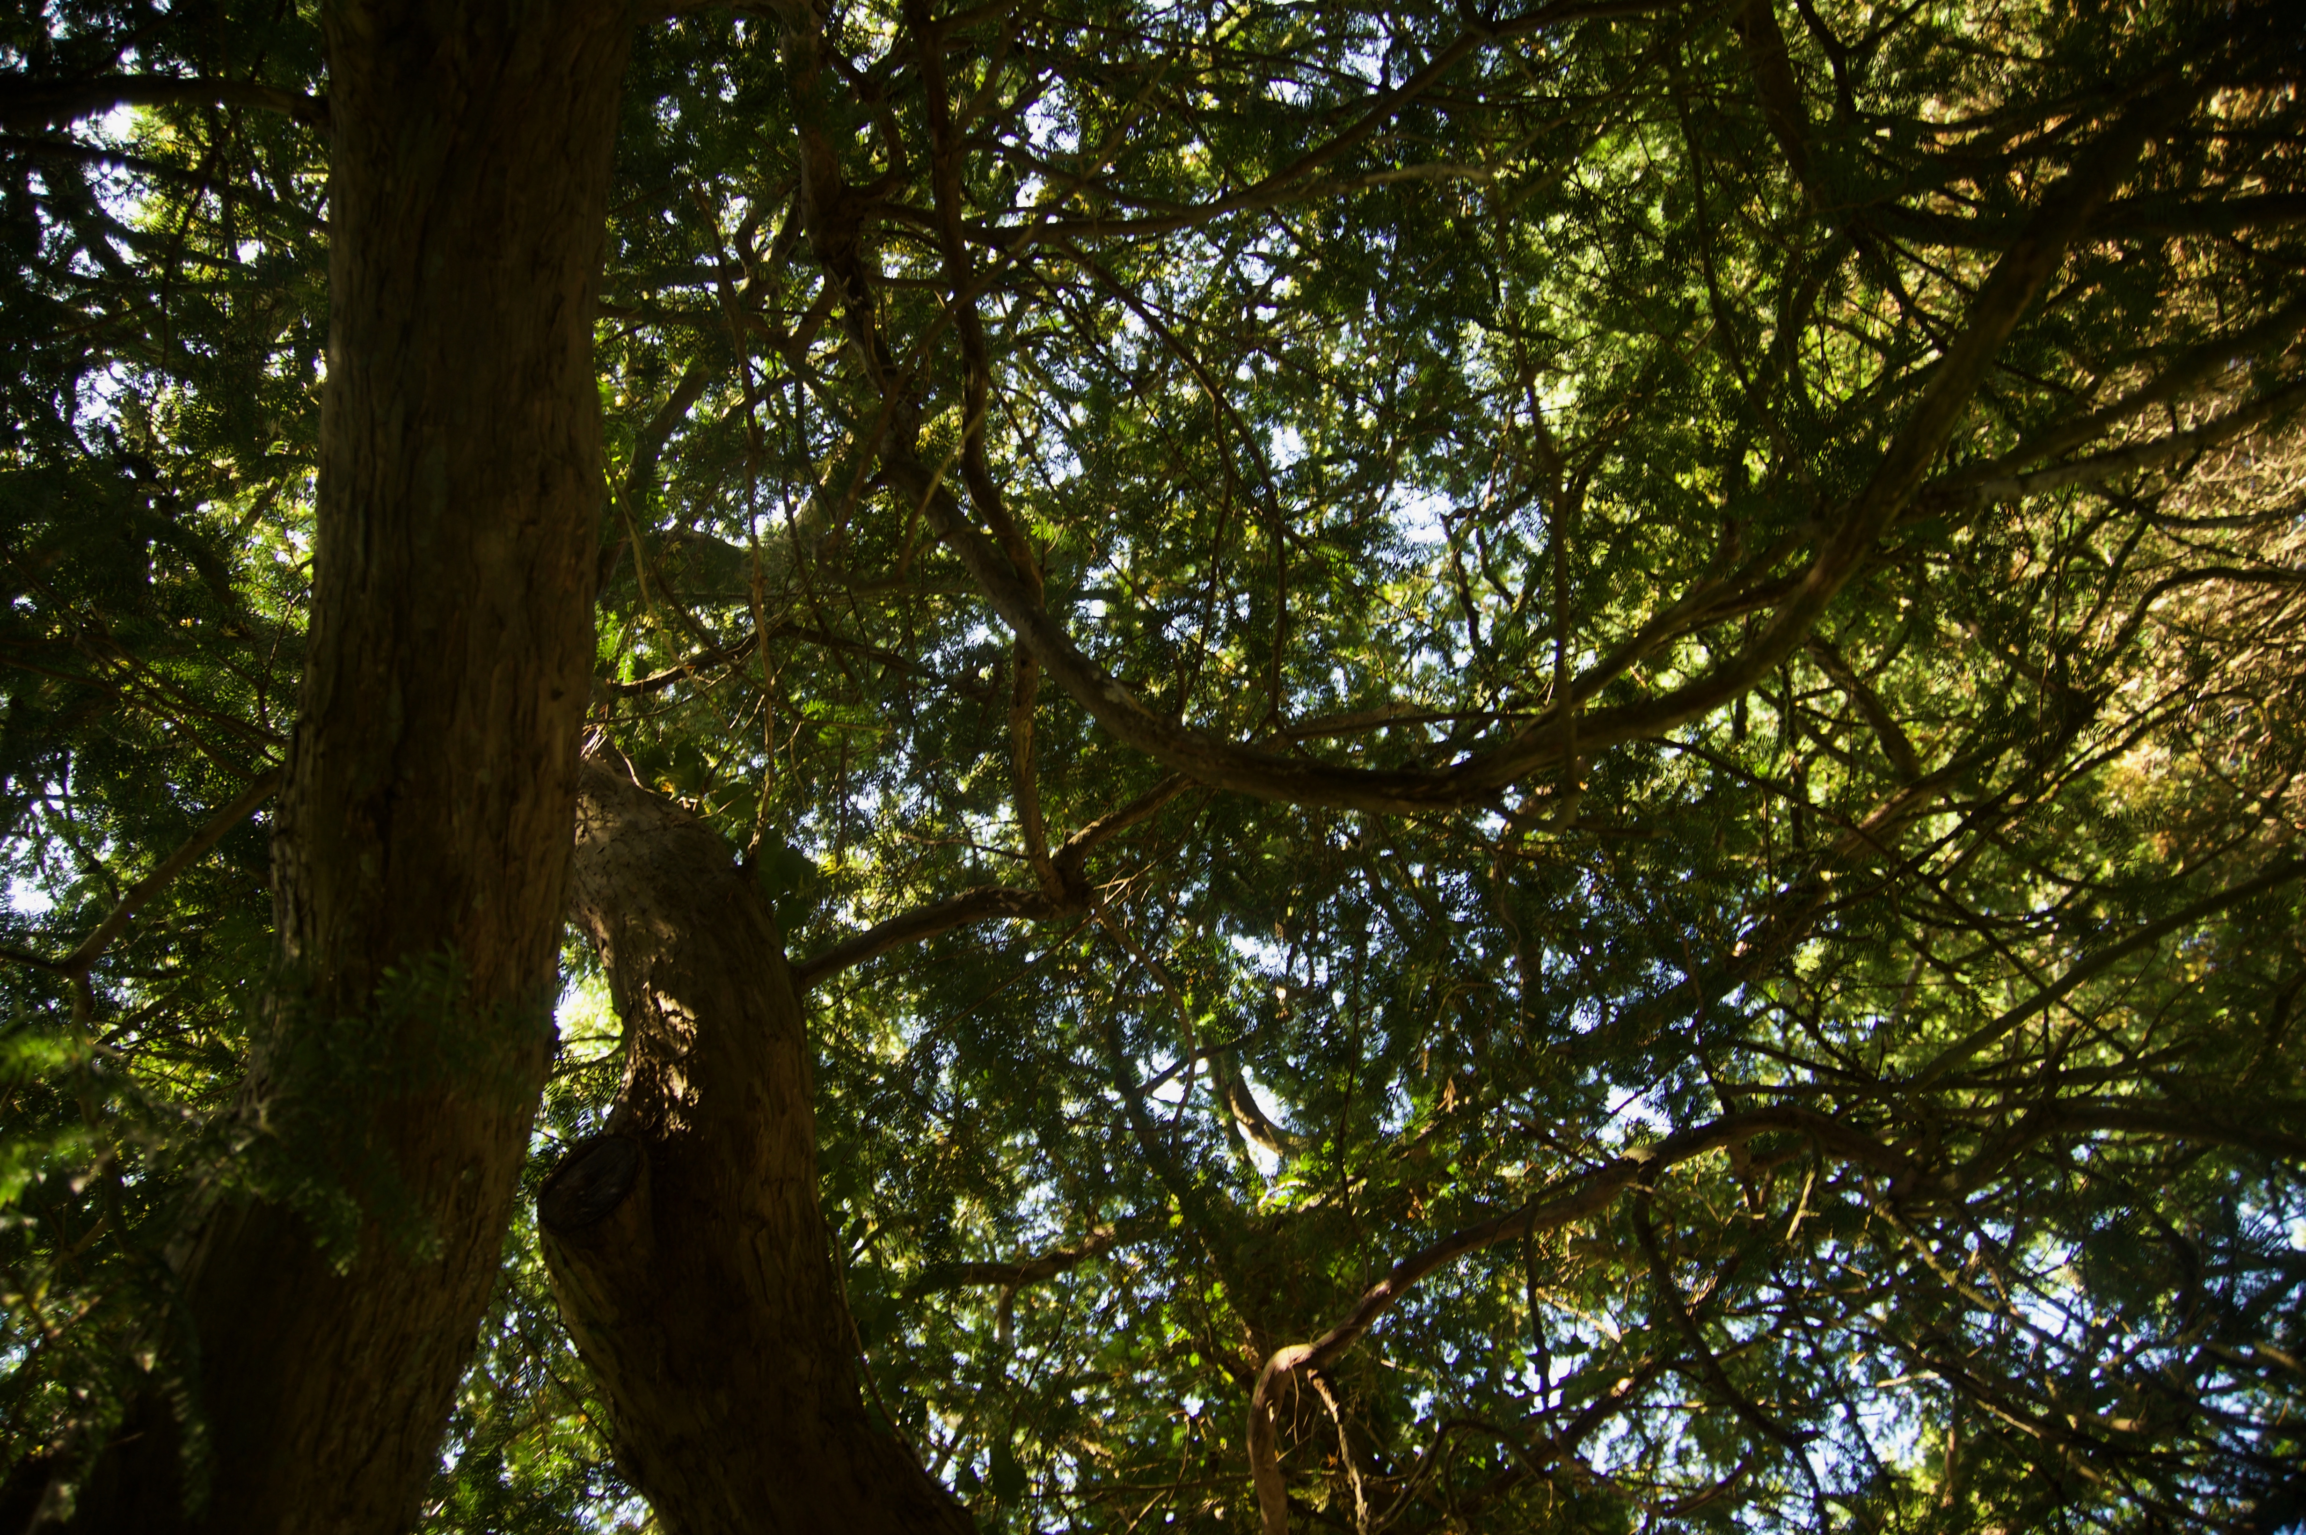
Fig. 1. Stewart, G. (2019) Untitled #1. [Photograph]. In: possession of: The author: Pembrokeshire.

Fig. 2. Stewart, G. (2019) Untitled #2. [Photograph]. In: possession of: The author: Pembrokeshire.

Fig. 3. Stewart, G. (2019) Untitled #3. [Photograph]. In: possession of: The author: Pembrokeshire.
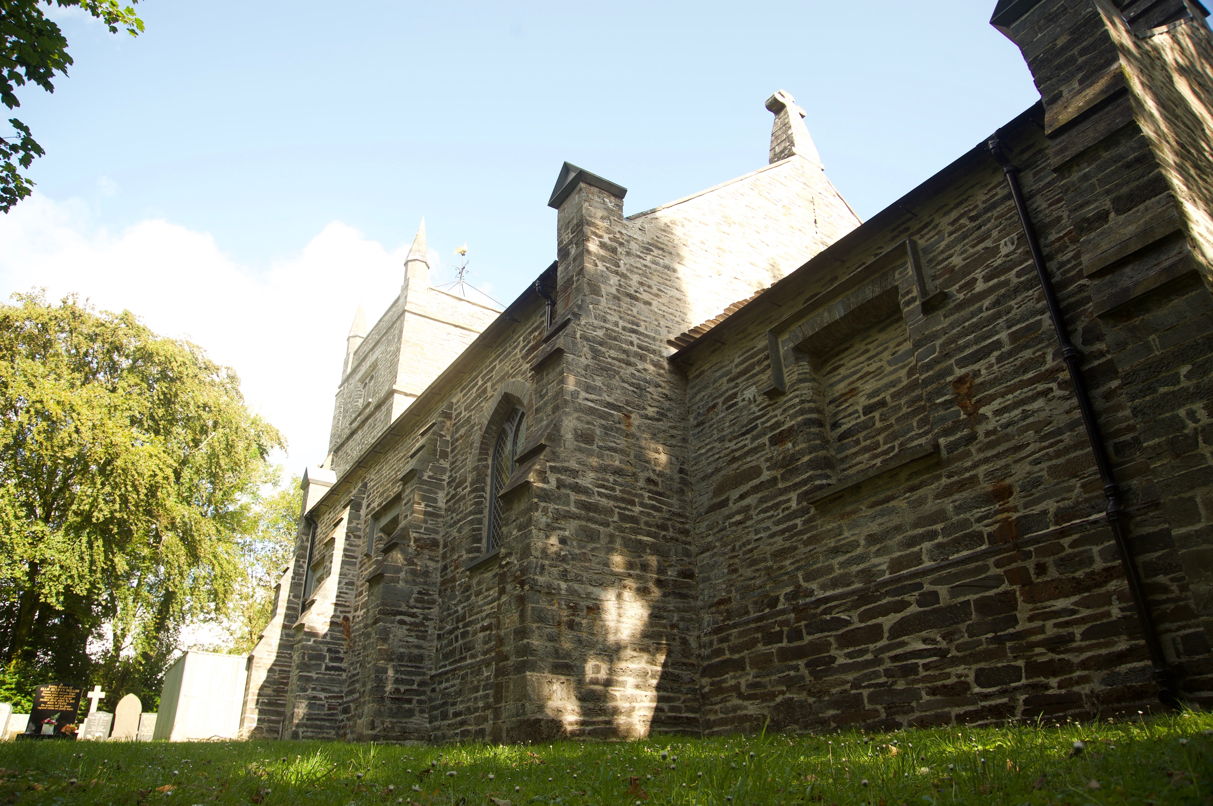
Fig. 4. Stewart, G. (2019) Untitled #4. [Photograph]. In: possession of: The author: Pembrokeshire.

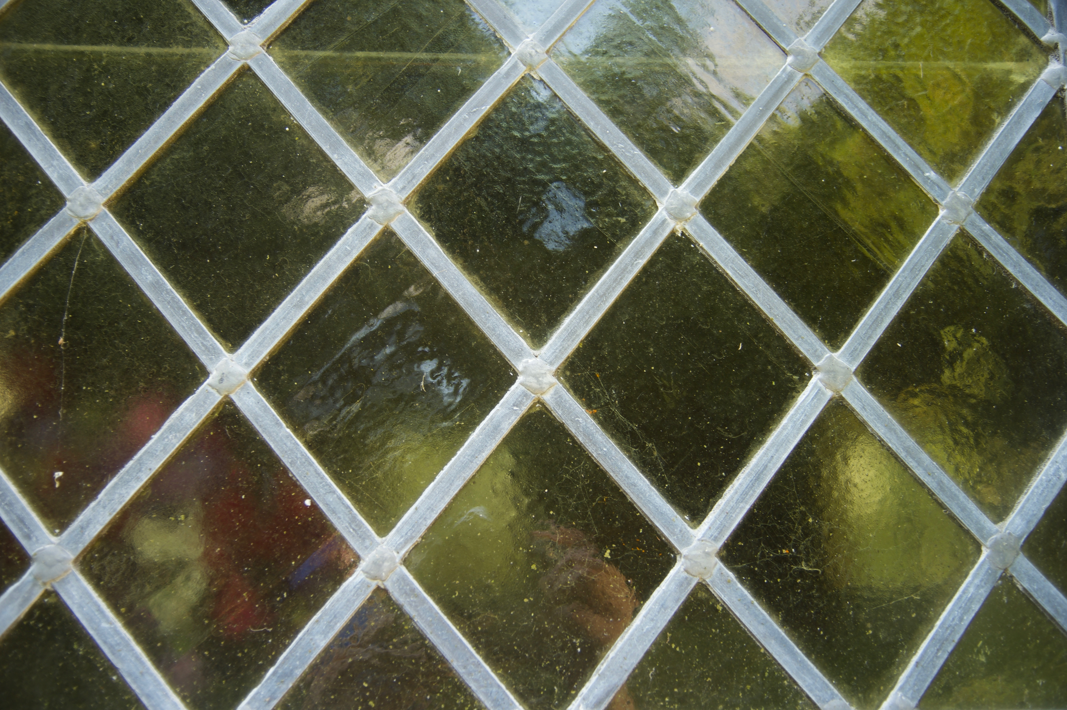
Fig. 5. Stewart, G. (2019) Untitled #5. [Photograph]. In: possession of: The author: Pembrokeshire.
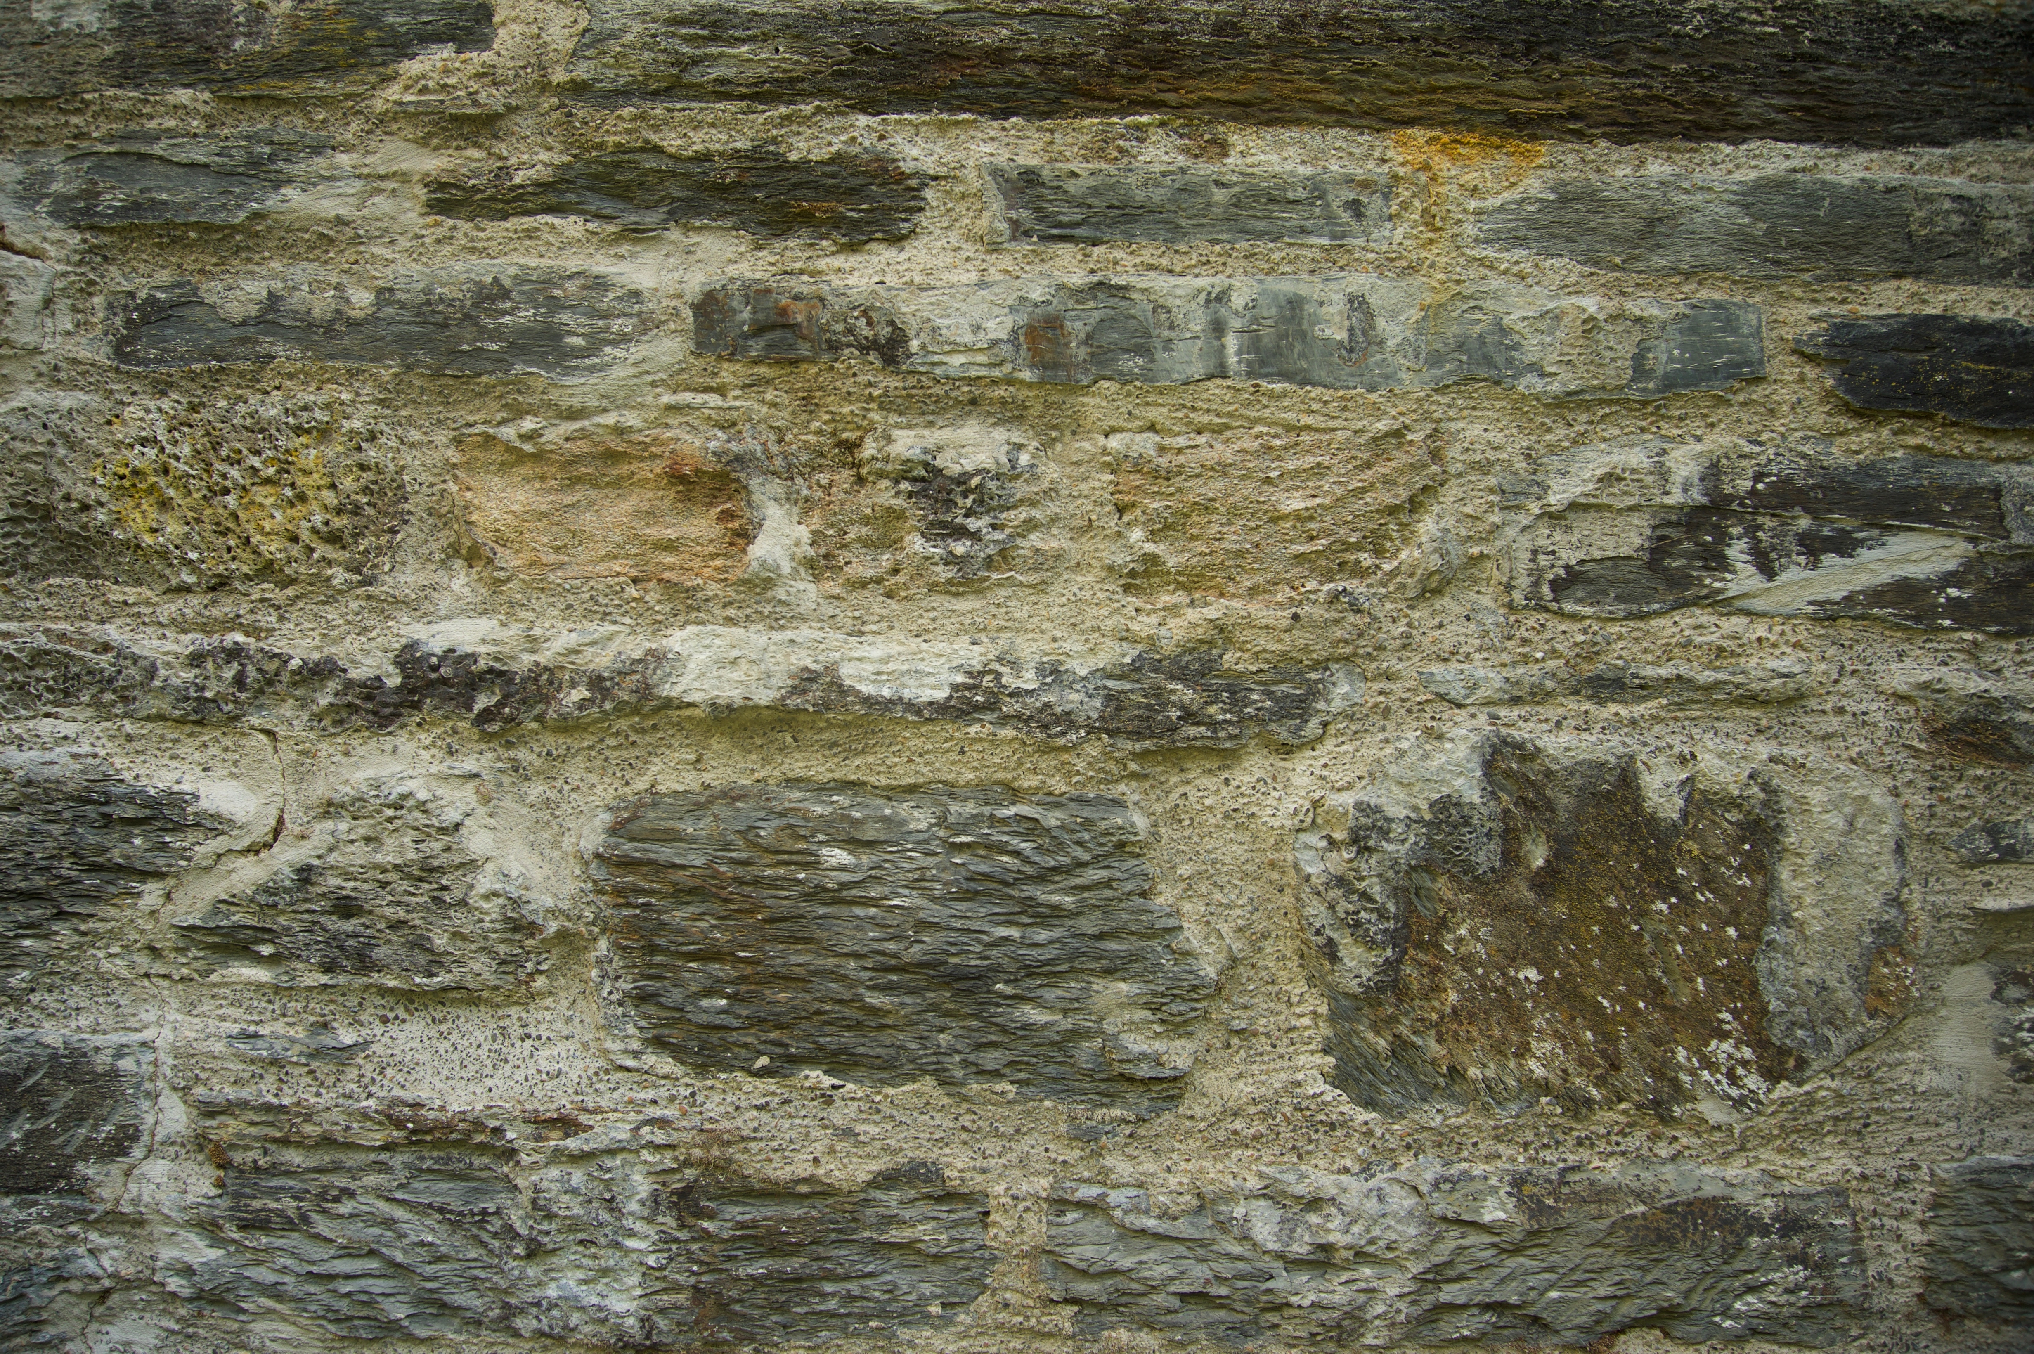
Fig. 6. Stewart, G. (2019) Untitled #6. [Photograph]. In: possession of: The author: Pembrokeshire.
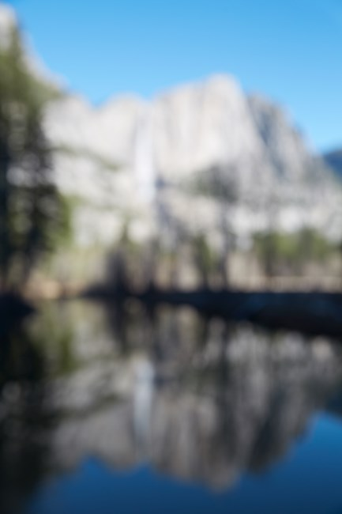
Fig. 7. Opie, C. (2015). Untitled #2 (Yosemite Valley). [Photograph - Online]. At: https://ocula.com/art-galleries/Lehmann-mauling/artworks/Catherine-opie/Untitled-2-yosemite-valley/ (Accessed on 24th of July 2019).

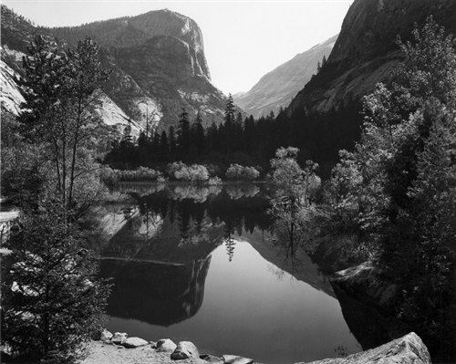
Fig. 8. Adams, A. (1925). Mirror Lake. [Photograph - Online]. At: https://shop.anseladams.com/mirror_lake_signed_special_edition_photograph_p/1701807106.htm (Accessed 24th of July 2019).

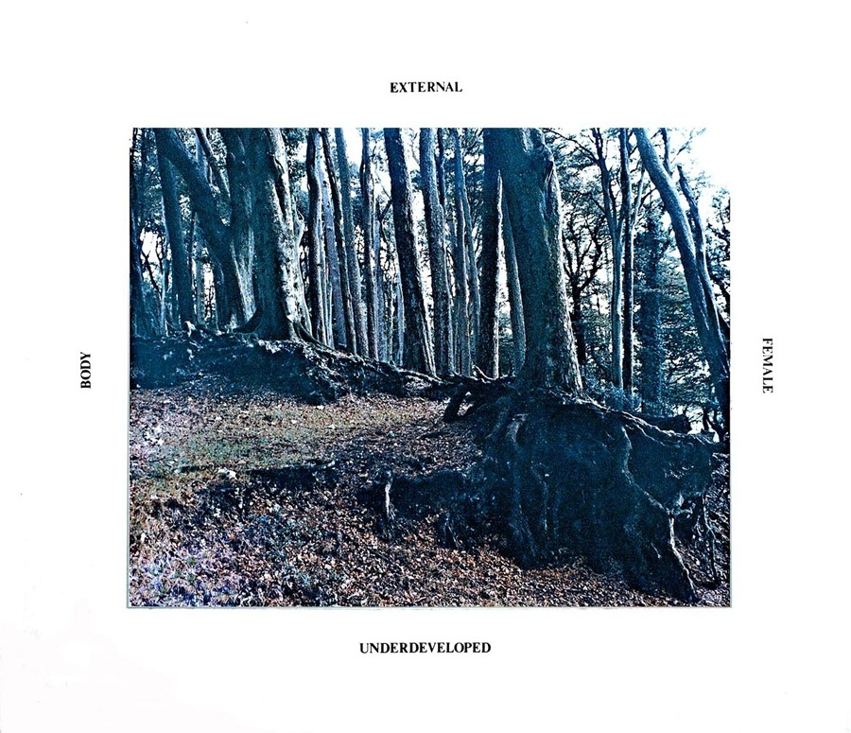
Fig. 9. Yates, M. (1976). Oppositional Frameworks 1. [Photograph - Online]. At: www.otenet.gr/~mystery/signalsproject1975.html (Accessed on 25th of July 2019).

Bibliography

Art Gallery NSW. Postmodernism. At: https://www.artgallerynsw.gov.au/education/learning-resources/education-kids/photography/postmodernism (Accessed on 6th of July 2019).
Benjamin, W. (2007) ‘The work of art in the age of mechanical reproduction’ In: Evans & Hall (ed.) Visual Culture: A Reader. London: Sage Publications Ltd. pp. 72-79.
Barthes, R. (2007) ‘Rhetoric of the Image’ In: Evans & Hall (ed.) Visual Culture: A Reader. London: Sage Publications Ltd. pp. 33-40.
Batchen, G. (1997). Burning with Desire: The Conception of Photography. USA: MIT Press.
Bate, D. (2010) ‘The Memory of Photography’ In: Taylor & Francis Online. 6th of September 2010. [Online]. At: https://www.tandfonline.com/doi/full/10.1080/17540763.2010.499609 (Accessed on 17th June 2019).
Berryman, A. (2011). What is Modernism? At: https://ashleighberryman.wordpress.com/2011/01/31/what-is-modernism/ (Accessed on 6th of July 2019).
Brooks, A. (2002). Postfeminism: Feminism, Cultural Theory and Cultural Forms. London: Routledge, p. i.
Buchanan, I. (2010). ‘Nihilism’ In: A Dictionary of Critical Theory. Oxford: Oxford University Press.
Dillet, B. I. MacKenzie & R. Porter. (2013) The Edinburgh Companion To Poststructuralism. Edinburgh: Edinburgh University Press.
Ebert, T. L. (1991). ‘The “Difference” of Postmodern Feminism’. In” College English (Vol. 53, No. 8) pp. 886-904. [Online]. At: https://www.jstor.org/stable/377692 (Accessed on 16th of July 2019).
Edwards, E. & J. Hart. (2004). Photographs Objects Histories: On the materiality of Images. London: Routledge, pp. 1-15.
Encyclopaedia Britannica. ‘Poststructuralism’ [Online] At: https://www.britannica.com/art/poststructuralism (Accessed on 19th of June 2019).
Green, J. (1978). ‘Photography as Popular Culture’ In: Journal of The University Film Association. Vol. 30, No. 4. [Online]. At: https://www.jstor.org/stable/20687447 (Accessed on 10th of July 2019).
Irvine, M. Approaches to Po-Mo. At: faculty.georgetown.edu/irvinem/theory/pomo.htm/ (Accessed on 19th of June 2019).
Killen, B. (2010). Postmodernism - Deconstruction and Fine Art Photography. At: www.bobkillenphotographyblog.com/2010/06/postmodernism-deconstruction-and-fine-art-photography/ (Accessed on 10th of July 2019).
McHugh, N. A. & P. Leaman. (2007). Feminist Philosophies A-Z. Edinburgh: Edinburgh University Press, pp. 100-103.
MDC. History of Modernism. At: https://www.mdc.edu/wolfson/Academic/ArtsLetters/art-philosophy/Humanities/history_of_modernism.htm (Accessed on 19th of June 2019).
P1. (2014) Postmodernist Art and Photography. At: https://www.photographicinspirations2014.wordpress.com/2014/03.31/postmodernist-art-and-photography/ (Accessed on 6th of July 2019).
Tam, P. So Long As They Are Wild. Catherine Opie. At: Art Asia pacific.com/magazine/WebExclusive/SoLongAsTheyAreWild (Accessed on 24th of July 2019).
Tate. Art Term - Modernism. At: https://www.tate.org.uk/art/art-terms/m/modernism (Accessed on 19th of June 2019).
Tate. Art Term - Postmodernism. At: https://www.tate.org.uk/art/art-terms/p/postmodernism (Accessed on 19th of June 2019).
Tate. Catherine Opie. At: htttps://www.tate.org.uk/art/artists/Catherine-opie-4641 (Accessed on 24th of July 2019).
The Art Story. Modern Photography. At: https://www.theartstory.org/movement-modern-photography.htm (Accessed on 6th of July 2019).
Tsui, E. (2018). Yosemite in all its intimacy: feminist photographer Catherine Opie’s first solo Hong Kong show features Western landscapes. At: https://www.scmp.com/culture/arts-entertainment/articles/2147211/Yosemite-all-its-intimacy-feminist-photographer-Catherine (Accessed on 24th of July 2019).
V&A. What is Postmodernism? At: https://www.vam.ac.uk/articles/what-is-postmodernism (Accessed on 19th of June 2019).
V&A. What was Modernism? At: https://www.vam.ac.uk/articles/what-was-modernism (Accessed on 19th of June 2019).
Willette, J. S. M. (2012). Postmodernism in Photography. At: https://arthistoryunstuffed.com/postmodernism-in-photography/ (Accessed on 6th of July 2019).
Woodward, D. (2016). The Artist using Landscape to make a Bold Feminist Statement. At: https://www.anothermag.com/art-photography/8790/the-Artist-using-landscape-to-make-a-bold-feminist-statement (Accessed on 25th of July 2019).

Illustrations

Fig. 1. Stewart, G. (2019) Untitled #1. [Photograph]. In: possession of: The author: Pembrokeshire.
Fig. 2. Stewart, G. (2019) Untitled #2. [Photograph]. In: possession of: The author: Pembrokeshire.
Fig. 3. Stewart, G. (2019) Untitled #3. [Photograph]. In: possession of: The author: Pembrokeshire.
Fig. 4. Stewart, G. (2019) Untitled #4. [Photograph]. In: possession of: The author: Pembrokeshire.
Fig. 5. Stewart, G. (2019) Untitled #5. [Photograph]. In: possession of: The author: Pembrokeshire.
Fig. 6. Stewart, G. (2019) Untitled #6. [Photograph]. In: possession of: The author: Pembrokeshire.
Fig. 7. Opie, C. (2015). Untitled #2 (Yosemite Valley). [Photograph - Online]. At: https://ocula.com/art-galleries/Lehmann-mauling/artworks/Catherine-opie/Untitled-2-yosemite-valley/ (Accessed on 24th of July 2019).
Fig. 8. Adams, A. (1925). Mirror Lake. [Photograph - Online]. At: https://shop.anseladams.com/mirror_lake_signed_special_edition_photograph_p/1701807106.htm (Accessed 24th of July 2019).
Fig. 9. Yates, M. (1976). Oppositional Frameworks 1. [Photograph - Online]. At: www.otenet.gr/~mystery/signalsproject1975.html (Accessed on 25th of July 2019).

